Pupil Premium Strategy Statement

This statement details Oaklands’ use of pupil premium funding to help improve the attainment of our disadvantaged pupils.

It outlines our pupil premium strategy, how we intend to spend the funding in this academic year and the effect that last year’s spending of pupil premium had within our school.

School overview
Detail | Data
School name | Oaklands Catholic School
Number of pupils in school | 1161
Proportion (%) of pupil premium eligible pupils | 16.7
Academic year/years that our current pupil premium strategy plan covers (3 year plans are recommended) | 2025-2028
Date this statement was published | December 2025
Date on which it will be reviewed | September 2026
Statement authorised by | Amy Bonnington
Pupil premium lead | Sadie Whyte
Governor / Trustee lead | Elizabeth Cluett
Funding overview
Detail | Amount
Pupil premium funding allocation this academic year | £190,575 (2025/26)
Recovery premium funding allocation this academic year  (Withdrawn by DfE for 2024/25) = | £0
Pupil premium funding carried forward from previous years (enter £0 if not applicable) | £0

Glossary of Terms
ARE Age Related Expectations

CATs Cognitive Abilities Tests

CATs are marked assessments used by schools to assess pupils’ overall intelligence, developed abilities and likely academic potential. Tests are taken in Year 7 and cover a range of questions covering Verbal Reasoning, Non-Verbal Reasoning and Quantitative Reasoning.

CPD Continuing Professional Development

DfE Department for Education

EEF Education Endowment Foundation

The Education Endowment Foundation is an independent charity established in 2011 to improve the educational attainment of the poorest pupils in English schools.

FFT Fischer Family Trust

The Fischer Family Trust is a non-profit organisation focussed on providing accurate information to schools to help inform teaching and policy.

FT Full Time

HAF Holiday Activities and Food (Programme)

A Government funded programme to provide support to children in receipt of free school meals through holiday periods.

IT Information Technology

KS2 Key Stage 2

MFL Modern Foreign Languages

PiXL A network of schools focussed on collaboration around leadership and shared support from Key Stage 1 to Key Stage 5.

PiXL (which stands for Partners in Excellence) aims to improve life chances and outcomes for young people and is committed to providing practical support and strategies to make an impact.

PP Pupil Premium

QFT Quality First Teaching

Quality First Teaching is a style of teaching that focuses on high quality and inclusive teaching for every child in a classroom.

SEN Special Educational Needs

SLT Senior Leadership Team

Part A: Pupil premium strategy plan

Statement of intent
Our intention is that all pupils, irrespective of their background or the challenges they face, make good progress and achieve high attainment across the curriculum, particularly in English and Maths.
The focus of our pupil premium strategy is to support disadvantaged pupils to achieve that goal, including progress for those who are already high attainers. We will consider the challenges faced by vulnerable pupils, such as those looked after, who have a social worker and young carers.
Quality First teaching is at the heart of our approach, with a focus on areas in which disadvantaged pupils require the most support. This is proven to have the greatest impact on closing the disadvantage attainment gap and at the same time will benefit the non-disadvantaged pupils in our school. Implicit in the intended outcomes detailed below, is the intention that non-disadvantaged pupils’ attainment will be sustained and improved alongside progress for their disadvantaged peers.
Our strategy is also integral to wider school plans for education recovery, notably in its targeted support through Tutoring Programmes for pupils whose education has been worst affected, including non-disadvantaged pupils.
Our approach will be responsive to common challenges and individual needs, rooted in robust diagnostic assessment, not assumptions about the impact of disadvantage. The approaches we have adopted complement each other to help pupils excel. To ensure they are effective we will:
- ensure disadvantaged pupils are challenged in the work that they’re set
- act early to intervene at the point need is identified
- adopt a whole school approach in which all staff take responsibility for
disadvantaged pupils’ outcomes and raise expectations of what they can achieve using the principles of Quality First Teaching

Challenges

This details the key challenges to achievement that we have identified among our disadvantaged pupils.
Challenge number | Detail of challenge
1 | Attendance and inclusion  Pupil Premium students at Oaklands are more likely to have lower attendance than their non disadvantaged peers.  They are also more likely to fall into persistent absentee categories.
2 | Improve the literacy & numeracy of targeted disadvantaged students  The disadvantage gap at Oaklands is small, however disadvantaged students are more still less likely to achieve ARE in English and Maths than their peers
3 | Continued professional development for staff in order to ensure that they are aware of the complex needs of some students and out preferred pedagogical approach to those challenges
4 | Addressing complex pastoral needs of some disadvantaged students- this requires additional support and intervention from our administrative and pastoral teams

Intended outcomes
This explains the outcomes we are aiming for by the end of our current strategy plan, and how we will measure whether they have been achieved.
Intended outcome | Success criteria
Reduced absence in disadvantaged students | Absence in disadvantaged students will be in line with peers, or where it is not, we will have a clear picture of factors affecting the targeted students’ attendance and have taken mitigating actions where possible.
Disadvantaged students will have improved literacy and numeracy outcomes | Disadvantaged students will make literacy and numeracy progress in line with non disadvantaged peers and we will make timely interventions to support students who are not making progress.
All staff at Oaklands will be aware of the challenges facing disadvantaged students and how these can be mitigated against. | Teaching and support staff will be trained in appropriate strategies to support PP students and will apply these strategies in their work with students.
Complex pastoral needs will be understood and young people with these needs will be supported in order to remove barriers to progress | Young people with complex pastoral needs will receive the pastoral support to remove additional barriers to learning.

Activity in this academic year
This details how we intend to spend our pupil premium (and recovery premium funding) this academic year to address the challenges listed above.

Teaching (for example, CPD, recruitment and retention)
Budgeted cost: £94,000
Activity | Evidence that supports this approach | Challenge number(s) addressed
CPD- disciplinary literacy and refreshed literacy strategy | EEF PP toolkit  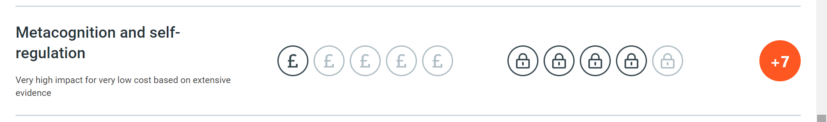  EEF literacy recommendations- embed disciplinary literacy across the curriculum  “All teachers should be supported to understand how to teach students to read, write and communicate effectively in their subjects. School leaders can help teachers by ensuring training related to literacy prioritises subject specificity over general approaches” | 2,3,4
CPD- staff to use Quality First Teaching principles | High quality teaching, differentiated for individual pupils, is the starting point in responding to pupils who have or may have SEN. Additional intervention and SEN support cannot compensate for a lack of good quality teaching.  Schools should regularly and carefully review the quality of teaching for all pupils, including those at risk of underachievement. This includes reviewing and, where necessary, improving, teachers’ understanding of strategies to identify and support vulnerable pupils and their knowledge of the SEN most frequently encountered.’  2015 government document Special educational needs and disability code of practice: 0 to 25 years. | 2,3,4
CPD- adaptive teaching  Staff to use adaptive strategies | 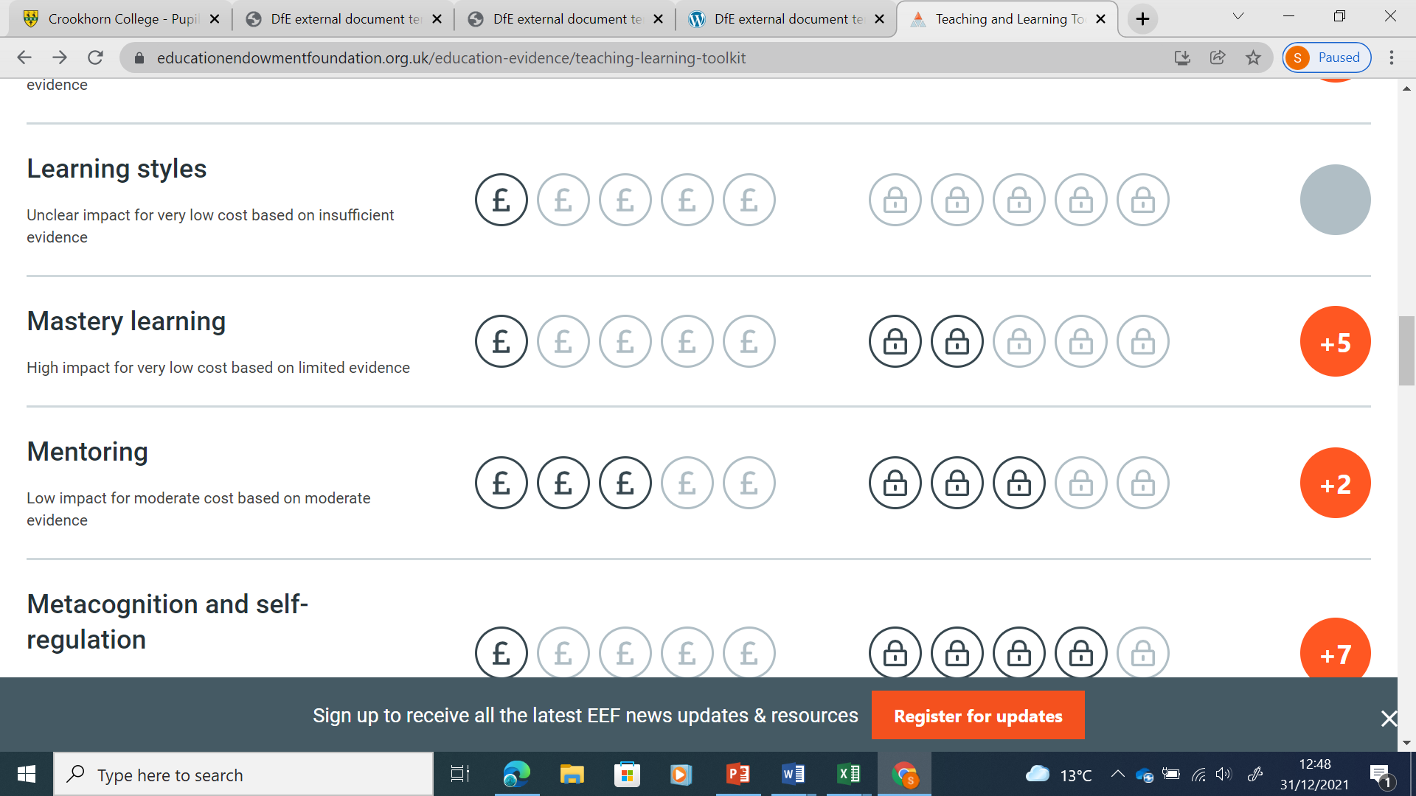 | 2,3,4
Recruitment and retention- specialist maths and science teachers to address staffing needs | Explicit teaching of Maths and Scientific vocabulary is identified as a key area of QFT. Specialist teachers ensure an authentic understanding in staff live modelling for students.  Pedagogical content knowledge is identified by Robert Coe in “Teach like a Champion” as key to QFT | 2,3,4

Targeted academic support (for example, tutoring, one-to-one support structured interventions)
Budgeted cost: £57,000
Activity | Evidence that supports this approach | Challenge number(s) addressed
Literacy and numeracy small group interventions offered for those who did not make end of KS2 ARE | 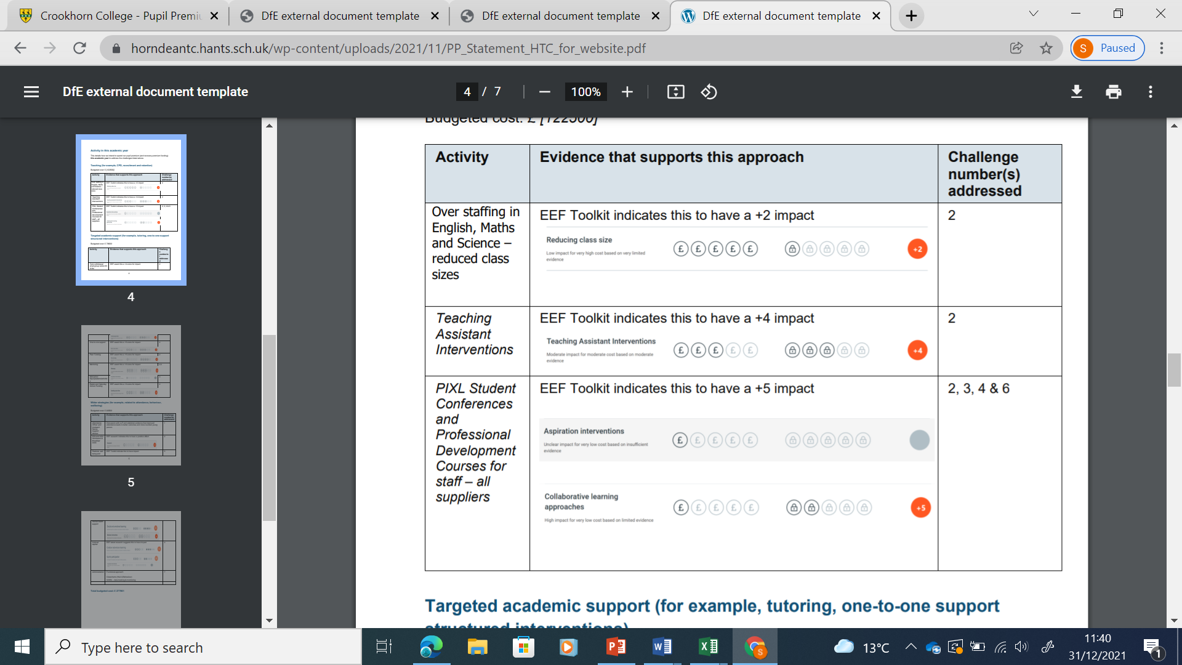  QFT model suggests different waves of intervention- this represents a tier 2 intervention to support those learners who needs it  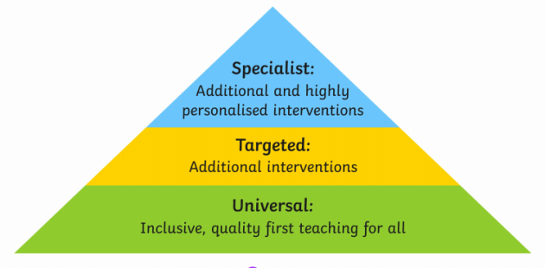 | 2,3
Small group and one-to-one interventions for those disadvantaged students who are also SEN/ vulnerable/ making poor progress | 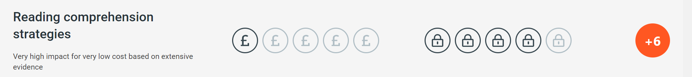  EEF literacy recommendations:  “Schools should expect and proactively plan to support students with the weakest levels of literacy, particularly in Year 7. Developing a model of tiered support, which increases in intensity in line with need is a promising approach. Assessment should be used to match students to appropriate types of intervention, and to monitor the impact of interventions. Creating a co-ordinated system of support is a significant challenge requiring both specialist input and whole school leadership” | 1, 2, 4
Summer Schools and HAF programmes | 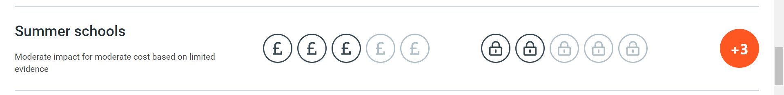  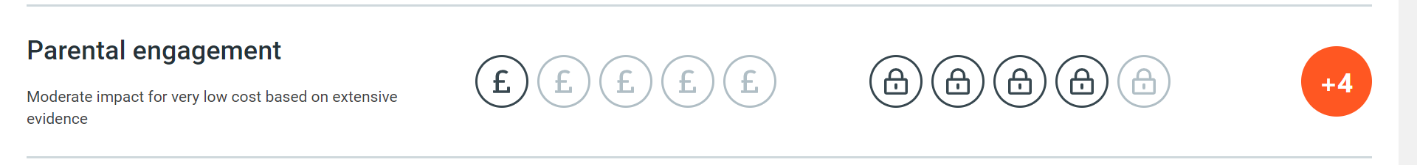  Offered to PP children coming to Oaklands as part of an extended educational and pastoral offer. | 1,2,4
Attitude to learning survey – Pupil’s Attitude to Self and Study | EEF suggests:  Considering a tiered approach to Pupil Premium spending can help schools balance approaches to improving teaching, targeted academic support, and wider strategies.  Surveying students allows precise diagnostic interventions | 1,2,4
Catch up CATs and diagnostic use of CATS data | Repeating CATs in year groups beyond year 7 for those who did not make ARE ensures that we have a more precise understanding of which interventions students may need | 2,3

Wider strategies (for example, related to attendance, behaviour, wellbeing)
Budgeted cost: £41,000
Activity | Evidence that supports this approach | Challenge number(s) addressed
Classcharts-  Rewards, behaviour, detentions and attendance trends are tracked by one system accessible to parents | EEF suggests a highly targeted and diagnostic approach to pupil premium. | 1,2,3,4
Rewards model  To motivate students and communicate success effectively to parents |  | 1,2,4
Specialist Pastoral support team (3 FT staff with attendance, wellbeing and behaviour support training) |  | 1,4
Administration and maintenance of DfE laptop scheme | EEF and government evidence states:  “Research has found that disadvantaged pupils have been worst affected by the impact of the pandemic”  Lack of access to IT equipment is fundamental to accessing online learning.  We retain and reuse these resources as best we can, and as they reach obsolescence, we replace them to provide our most vulnerable students with a laptop where possible on a case by case basis. | 1,4
Young Carers support group and Oaklands Armed Forces Group |  | 1,4
SLT/ senior staff mentors for students with poor progress in Year 11

Total budgeted cost: £192.000

Part B: Review of outcomes in the previous academic year

Pupil premium strategy outcomes
This details the impact that our pupil premium activity had on pupils in the 2024 to 2025 academic year.
In 2024/25 the (provisional) Oaklands PP progress gap was -0.9 compared to a 22/23 gap of -0.6. This represents a widening of the PP progress gap at Oaklands. This is due in part to the particularly complex and ‘doubly disadvantaged’ status of those students, and a growth in the size of the pupil premium cohort. It is of course to be noted that when describing the widening of a gap we are of course describing the progress of an entirely new cohort of children. Early indications for results in 2026 are that this gap will narrow.
It is noted that a significant number of our PP students were provided with a DfE laptop during the course of the 2021/22 academic year and they may have suffered gaps in their learning until this provision reached them. It is therefore difficult to accurately quantify the impact of the pandemic on this vulnerable group as they took their GCSE exams in the summer of 2025.
The cost of living crisis has had a direct impact on the pupil premium cohort at Oaklands, which has grown, and pupil premium funding has been used to meet some of the most fundamental barriers to learning on a case by case basis, such as bus passes, as well as our strategic overview to improve learning outcomes for the whole PP cohort.
Pupil premium attendance has been a key area of activity, and we have expanded our staffing in this area to ensure that we have well trained attendance officers who follow up on all vulnerable and pupil premium student absences and those of persistent absentees. We have also trained teaching staff to immediately alert the attendance team and on-call SLT when PP and other vulnerable students are unaccounted for and use our investment in ClassCharts to follow this up. Our investment in Fischer Family Trust targeting software also means that we are able to set and maintain rigorous targets for attendance and attainment for our pupil premium students, and although we do have a number of PP persistent absentees (those whose attendance falls below 90%) our numbers are lower than the national and local authority averages.
It is to be noted that a PP specific revision intervention in English, the St Anthony’s group, can be seen to have made a direct impact on PP progress in English language and literature where the PP gap sharply closed. The majority of students who accessed this support attained a strong or standard pass. Student and staff feedback was that this support was well received and boosted confidence and had impact, particularly when embedding and securing new knowledge.
Pupil premium funding of 50% of the cost of peripatetic music lessons is ongoing and there has been substantial uptake of these lessons over the last year. Numbers of PP students participating in concerts and music groups to showcase talent have increased and 6 students of 15 in our last concert were PP.
The intervention group, a core staff group of the curriculum deputy, SENCO and HODS of English and Maths meet on a fortnightly basis to discuss the appropriate learning interventions and track the progress of PP and other vulnerable students and this has meant that we are able to address whole school priorities on a case by case basis after each data drop.
We have invested in CPD staff training in teaching approaches for children with ADHD, children with significant trauma and attachment issues and neurodiverse children. PP children are over-represented in these areas, and this work has been well-received by staff, who are more confidently able to adapt teaching approaches to take account of student needs.

Externally provided programmes
Please include the names of any non-DfE programmes that you purchased in the previous academic year. This will help the Department for Education identify which ones are popular in England
Programme | Provider

