Our Ref: DP/DMB 4th January 2023
Dear Year 11 Parents/Carers

As time draws on, we are coming closer to the exam season. As you are aware, your son/daughter will be the second cohort to sit exams since 2019 and will not be receiving any additional support or advance information from the exam board. They have been thoroughly taught by the RE staff across the two years and will have finished the syllabus by February half term 2023. However, there have been periods of time when students have been ill and forced to isolate and miss lessons. Thus, they will have at least nine weeks in class to review all the topics and undertake revision. Moreover, as I am sure you are aware, revision needs to be an ongoing process, and so revision at home is also of paramount importance.

To this end, I would ask you to read the information below and decide, with your son/daughter, which actions you wish to take to enable them to achieve the best possible results in the summer.

All students in sets 1 to 4 will sit AQA specification A Religious Studies, which consists of:

Paper 1: Catholic Christianity Beliefs and Practices + Judaism Beliefs and Practices (1 hour 45 minutes) – Monday 15th May 2023
Paper 2: Themes: Religion & Life, Revelation & the Existence of God, Peace & Conflict, Crime & Punishment (1 hour 45 minutes) – Tuesday 23rd May 2023

Every student has access to the online textbooks and exam resources (via Kerboodle) we have paid for, which will cover Paper 1: Judaism beliefs and practices and Paper 2: Themes. There are also many elements of Catholic Christianity across the two textbooks, although there are specific sub-topics which are not covered. With this in mind we have created six bespoke revision workbooks which are intended to help students create their own revision notes. Each workbook contains key words, quotations, sample exam questions and guided activities to complete revision tasks.

The six workbooks (in A4 booklet form with colour copying), together with a plastic folder to keep them in is available to order from the school finance office at a cost of £5.00. However, should you wish to print them yourself, they are available free of charge on Teams, Class Charts and the school website. All students in sets 1-4 are expected to have these workbooks for use in class after February half term.

You will find on Class Charts and Teams a variety of other resources including many online resources and video links to allow students to revise in the way that best suits them, as well as past papers to allow them to apply and test their learning.

There is also an AQA Religious Studies Spec A revision guide which you can purchase from Amazon at the price of £9.99 should you wish, although there is no expectation that you will do so. Details are below.

Those families who qualify for pupil premium funding under the free school meal criteria or have been in receipt of free school meals in the last six years, are eligible to receive a 100% subsidy of the cost of both the resources.

Free school meals criteria
• Income Support
• Income-based Job Seekers Allowance
• Income-related Employment & Support Allowance
• Support under Part VI of the Immigration & Asylum Act 1999
• the Guaranteed element of State Pension Credit
• Child Tax Credit, provided you are not also entitled to Working Tax Credit and have annual gross income of no more than £16,190 as assessed by Her Majesty’s Revenue & Customs
• Working Tax Credit run-on-paid for 4 weeks after you stop qualifying for Working Tax Credit

Finally I have attached the RE Department revision workshop schedule which will continue until the exams in May. As you can see there are multiple opportunities to attend the different topics, hopefully meaning there is a time to suit your son/daughter whilst juggling their other commitments.

As always you are welcome to contact me should you wish to discuss any element of the revision process or the exams. My email is d.palfreyman@oaklandscatholicschool.org

Please complete and return the form to the Finance Office by Monday 6th February since this is the week before half term and thus resources will need to be prepared and ready for use on return after half term. Our preferred method of payment is online. Alternatively, you can pay by cash or cheque (made payable to Oaklands Catholic School).

With many thanks for your ongoing support

Yours sincerely
Mrs Deborah Palfreyman (Head of RE)

ISBN: 978-0-198432548

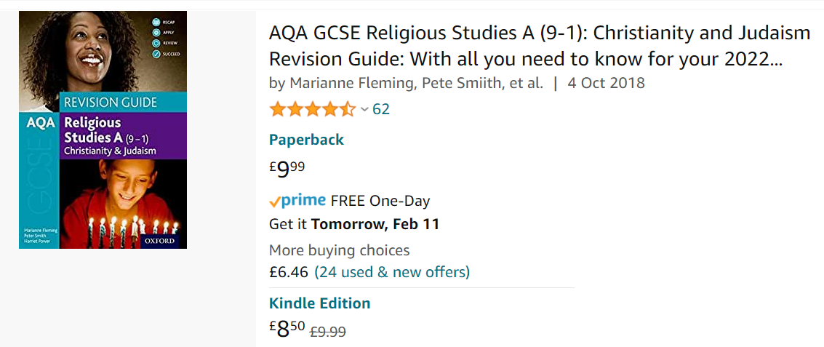

PLEASE RETURN TO THE FINANCE OFFICE

Religious Studies GCSE revision workbook pack

Student Name:…….……………………………………………………Form………………

Payment of £5.00 is enclosed I have paid £5.00 on line

I wish to apply for Pupil Premium

Parental Signature: ……………………………………………….…… Date………………

