
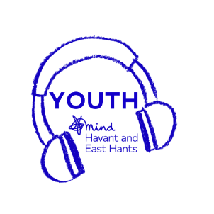
Young Person’s Safe Haven
Young Person’s Information Sheet

Young Person’s Safe Haven has some exciting news... we are returning to our drop-in service on Tuesday 19th of October.
You do not need an appointment or a referral!
Young Person’s Safe Haven is a drop-in crisis mental health service for 11- to 17-year-olds living within the Havant borough.
To attend Young Person’s Safe Haven just simply come to The Pallant Centre within our opening hours and ring the Mind doorbell
During your first visit you will have a confidential chat about why you have come to Young Person’s Safe Haven and you will be asked to give some personal details (if you are happy to do so). You can bring in another person for support if you would like to however you can attend on your own.
After the confidential chat you will be able to access all parts of Young Person’s Safe Haven!
Each evening we will offer one-to-one mental health support sessions, wellbeing groups, mindfulness, art & craft sessions, a chance to meet other young people in a calm safe space
The evening will follow:
5pm to 7:30pm – One-to-one support session are available through the evening
5pm to 6pm – Small wellbeing activities and a calm, quiet space
6pm to 7pm – Wellbeing Group Sessions including a range of wellbeing topics
7pm to 7:45pm – Arts and craft session, get creative and make something that can be taken home with you
7:45pm to 8pm – the last 15 minutes are to relax and wind down with a mindfulness session before you leave at 8pm
Opening Hours:
5pm to 8pm every Tuesday, Wednesday and Thursday
Location:
The Pallant Centre, Havant PO9 1BE

If you have any questions, please speak to a member of staff
Telephone: 0300 303 1580
Email: cypsafehaven@easthantsmind.org
Please note our email and telephone are only monitored during our opening hours

