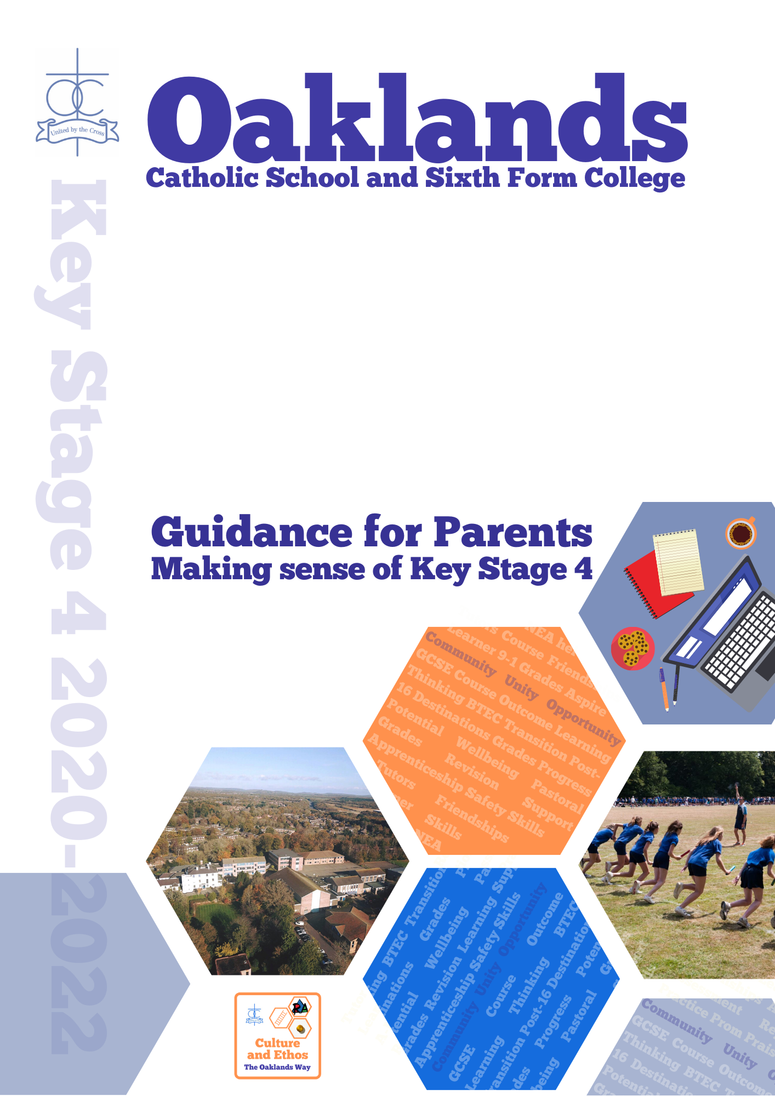


Dear Parents and Carers

These next two years are a time of great change and development for your son or daughter, both academically and personally and as such, boundaries will inevitably change, relationships will change and new pathways will emerge to be followed. Your child will be making new friends and you may notice changes in their peer groups as they mix with students from across the year. You will hear them speak using new terminology about their work and their outlook about school and life beyond will have to be reconsidered. This is a time of great transition and both you and your child will have to learn to manage this. Hopefully we will help equip you with new tools and advice on how to handle these changes. All relationships at this time are dynamic and fluid and you will need to be flexible in adapting to the changes but also maintain stability and consistency in your boundaries.

On behalf of the pastoral team, the teaching staff and all members of the Oaklands community we hope that this time of transition will strengthen and reinforce the positive relationships that we have forged together with your child’s best interests at the heart of all we do. This is an opportunity for us to re-energise the partnership between home and school and turn it into a partnership for progress.

This booklet is designed to be an aide-memoire with handy tips, signposts and contacts for you to use in the future. It is important to remember that we as a school are always here to help and support you; together we can achieve great things and we have a mutual objective: to develop your son or daughter’s best potential, to help them be the best that they can be.

Community, Unity, Opportunity – that’s what Oaklands is all about

If you wish to discuss further any issues, do not hesitate to contact your child’s tutor (using our email facility; see addresses in this booklet and on our website) or Mrs Riddle (Head of Year) and they will work to resolve or answer any questions.

With best wishes

Mr M Quinn and Mrs A Bonnington
Headteacher Deputy Headteacher

Key Stage 4

Pastoral Support at Oaklands

‘The school’s behaviour policy aims to build and develop self-regulating student behaviour to a high standard, in readiness for greater independence granted in the adult work place or post-16 learning environment. If we can equip students with the personal skills to behave and work well of their own volition here, they stand more chance of enjoying and achieving in their lives.’ (Governors' Student Behaviour Policy)

Pastoral Support is the care which is given to the well-being and happiness of each student. At Oaklands we have a model of Pastoral Care which involves working very closely with a wide range of people and agencies to ensure that each child is able to focus on their learning and achieve their potential.

The most significant features are:

- The Head of Year and form tutors, wherever possible, remain with their classes from Year 7-11.

- Heads of Year are supported by form tutors and link tutors.

- Non-teaching pastoral support staff.

- Close and effective working relationships with external agencies.

- A Behaviour Team to ensure problems are identified early and interventions put in place.

- Learning Support from the Bartimaeus Centre is actioned by the SENCo.

- The Pastoral Teams meet regularly and identify students who are in need of additional support, particularly if there are difficult home circumstances, mental health issues or social / emotional issues affecting learning.

- Parents are notified quickly when problems arise and the school constantly seeks ways to work more closely with parents in addressing any areas of concern.

- The Oaklands Way, the Code of Conduct, Restorative Justice, Rewards and Sanctions procedures to ensure consistency of approach.

- ‘At Oaklands, we consider that it is important to form good links between home and school and work in partnership with parents. Parents will be kept fully informed about inappropriate behaviour and encouraged to support the school and their children. We recognise that parents, as primary educators, have a direct and powerful effect on child behaviour. It is the school’s role to support parental responsibility.’ (Governors' Student Behaviour Policy)

PASTORAL CARE

DEPUTY HEAD (Pastoral and Designated Safeguarding Lead)
Mrs Bonnington

ASSISTANT HEAD (Oversight for disadvantaged students)
Mrs Whyte

SENCO
Mrs Rowsell

YEAR TEAM

HEAD OF YEAR
Mrs Riddle

LEAD TUTOR
Mrs Mooney

FORM TUTORS
Mr Forster (Ca)
Mr Finch (Cl)
Mr Dawson (Do)
Mrs Mooney (Mg)
Mrs Bell (Mt)
Mr Kennedy (St)
Mrs Iwara (Te)
Mr Whelan (Vp)

LINK TUTOR
Mrs Whelan

PASTORAL, WELFARE AND BEHAVIOUR SUPPORT

Mrs Standen – Safeguarding and Welfare Manager
Mr Miller - Pastoral Support Officer
Mrs Nicholls -Inclusions Manager
Mrs Rigby - Emotional Literacy Pastoral Assistant
Mr Jones – Attendance & Alternative Provision Manager

If you are concerned about the impact poor behaviour, emotional issues or family problems are having on your child, please do contact your son / daughter’s form tutor or Head of Year in the first instance.
Don’t leave it too late – KS4 is a relatively short but critical period of time in their education and it is better to come into school and discuss any issues as soon as they arise.
Contact emails for the year team are below:
Mrs Riddle  Head of Year | 18HoY@oaklandscatholicschool.org
Mr Forster (Ca) | 18Ca@oaklandscatholicschool.org
Mr Finch (Cl) | 18Cl@oaklandscatholicschool.org
Mr Dawson (Do*) | 18Do@oaklandscatholicschool.org
Mrs Mooney (Mg) | 18Mg@oaklandscatholicschool.org
Mrs Bell (Mt*) | 18Mt@oaklandscatholicschool.org
Mr Kennedy (St) | 18St@oaklandscatholicschool.org
Mrs Iwara (Te) | 18Te@oaklandscatholicschool.org
Mr Whelan (Vp*) | 18Vp@oaklandscatholicschool.org
*New tutors at the start of KS4



Is your child studying for GCSEs?
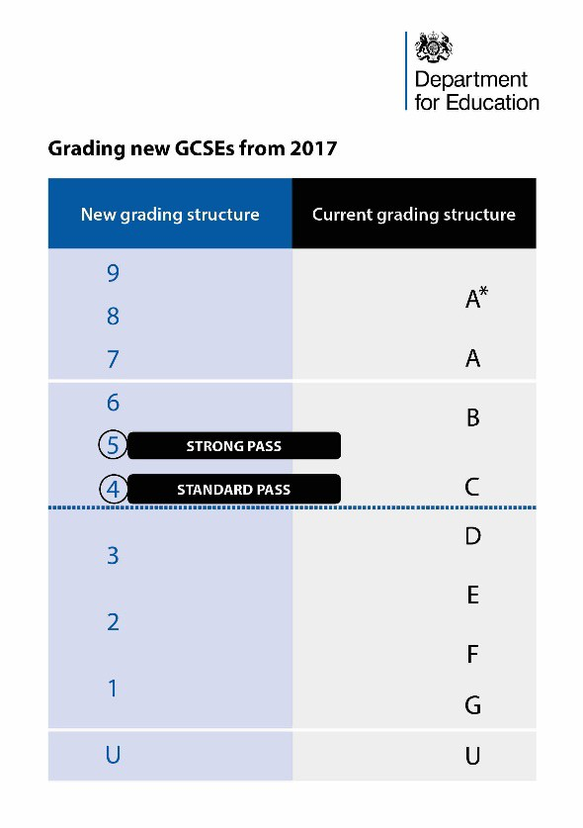
The courses and exams have been changed to ensure that young people have the knowledge and skills they need to succeed in the 21st Century. The new GCSEs will ensure that students leave school better prepared for work or further study. They cover more challenging content and are designed to match standards in the strongest performing education systems elsewhere in the world.

Top facts about the GCSEs

- GCSEs in England have a 9 to 1 grading scale, to better differentiate between the highest performing students and distinguish clearly between the new and old exams.

- Grade 9 is the highest grade and is awarded to fewer students than the old A*.

- The old and new GCSE grading scales do not directly compare but there are three points where they align, as the diagram shows:
  - The bottom of grade 7 is aligned with the bottom of grade A;
  - The bottom of grade 4 is aligned with the bottom of grade C; and
  - The bottom of grade 1 is aligned with the bottom of grade G.

- Although the exams cover more challenging content, this won’t mean
your child gets a lower grade than they might have under the old
system. Ofqual, the exams regulator, will ensure that broadly the same
proportion of students will get grades 1, 4 and 7 and above in any
subject as would have got grades G, C or A and above respectively in
the old system, other things being equal.

- The Department for Education recognises grade 4 and above as a ‘standard pass’; this is the minimum level that students need to reach in English and Maths, otherwise they will need to continue to study these subjects as part of their post-16 education. There is no re-take requirement for other subjects

- Employers, universities and colleges will continue to set the GCSE grades they require for employment or further study.

- For measuring school performance, we will publish the proportion of students achieving a grade 5 and above. The Department for Education recognises grade 5 and above as a ‘strong pass’, a benchmark in line with the expectations of top performing education systems around the world – this will be one of the headline measures of school performance. We will also publish the proportion of students achieving a grade 4 or above for transparency and to enable schools to show their students’ achievement.

.
Target Grades and Reporting Dr A Howson

GCSE - Target Grades

This year group will be assessed in their GCSEs under the grades 9-1 regime.

In the Autumn Term of Year 10, your child (in discussion with subject teachers) will be assigned a minimum target grade that will be assigned to all of their GCSE courses. This target should be recorded in the student planner but will be formally reported home to parents in the Autumn Term. These target grades are based on your child’s prior attainment and should be both challenging and aspirational – a real ‘Best Case Scenario’ outcome. If you require any further information regarding your child’s target grades, subject specific enquiries should be directed to the subject teacher. If your enquiry is of a more general question regarding target setting, please contact Dr A. Howson

KS4 - Reporting Cycle

The following Reporting cycle is currently in use across KS4:

Grades for Present attainment, Learning behaviour and Homework – each half term.

Additionally:

- Autumn Term Y10 - targets grades, present attainment grades.
- First Half of Spring Term Y10 - present attainment grades.
- End of Spring Term Y10 – predicted grades (for end of Y11).
- First half of Summer Term Y10 – present attainment grades.
- Summer Term Y10 – Y10 Parents’ Evening - students collect and record targets for improvement in each subject.
- End of Summer Term Y10 – end of year Exam Grades
- Autumn Term Y11 - subject comments and predicted GCSE outcome.
- First Half Spring Term Y11 – Practice exam grades and predicted GCSE outcome. Present attainment grades
- Spring Term Y11 – Y11 Parents’ Evening – students collect and record targets for improvement in each subject.
- Summer Term Y11- final GCSE predictions plus written report from the Form Tutor.

Examinations at Key Stage 4 Mr M Bamford

Internal exams will take place at regular intervals during the 2 years of Key Stage 4. These ‘mock’ exams are important stages in enabling staff to gauge student progress and attainment and also to help students learn to deal with the demands of the full terminal exams at the end of their courses. Formal public examinations will take place in May and June at the end of Year 11, with some subjects also having coursework or controlled assessment tasks throughout the two year courses. There are 2 key points arising from this. Firstly, students must be well aware of which subjects are setting controlled assessments, when, and to do this they should refer to subject teachers. Secondly, the importance of practice exams is heightened as the only opportunities to have a practice run at GCSE assessment and students must take these seriously. Therefore, it is completely ill-advised to apply for holiday leave during term time due to the risk of missing essential work immediately before exams, or even the exams themselves. Where coursework and controlled assessment is used in subjects, the work should be approached seriously and submitted on time, as all marks count towards final grades. Once again, a student missing this work due to a term time holiday / absence is putting at serious risk their chances of full exam success.

All students will receive statements of entry showing the subject, date and time of their exams. They must check this carefully and notify teaching staff of any queries or errors. If a student misses an exam due to a complication over timing of their own fault, no allowance can be made. Over the course of a school year students are issued with several documents about practice exams and public exam entries. Students have a responsibility to share with their parents or carers all exam information. Any possible queries about entries can then be addressed to subject teachers as soon as possible after receiving the entry information to avoid last minute confusions and changes. Special consideration is only given by exam boards in the case of sudden and severe illness, or circumstances of a significant nature that interfere with a student’s ability to perform well in or sit the exam. Equally, the allowances made are minimal, awarding to a maximum of 5% additional marks.

It is our intention to post on the Oaklands website the overall exam timetable when the provisional dates have been confirmed in order to help students plan ahead. However, even with the best planning, some minor changes may be made by the exams boards, so students must keep checking the website and pay close attention to all statements of entry that are issued to them.

Each exam board has useful areas to aid students and parents in understanding the examinations and assessment system.

- http://www.ocr.org.uk/ocr-for/learners-and-parents/
- http://www.aqa.org.uk/student-support
- http://www.edexcel.com/i-am-a/student/Pages/home.aspx
- http://resources.eduqas.co.uk/

Key Stage 4 Overview

Further information will be available on the school website and via the exam board websites
 | %  Controlled Assessment | %  Practical Assessment | % Exam
Art | 60 |  | 40
Business and Economics |  |  | 100
Computing |  |  | 100
D&T: Electronic Products | 50 |  | 50
D&T: Food Preparation and Nutrition | 50 |  | 50
D&T: Resistant Materials | 50 |  | 50
D&T: Textiles | 50 |  | 50
Dance |  | 60 | 40
Drama | 40 | 20 | 40
English Language |  |  | 100
English Literature |  |  | 100
English |  |  | 100
French |  |  | 100
Geography |  |  | 100
Child Development | 50 |  | 50
History |  |  | 100
Computing | 60 |  | 40
Maths |  |  | 100
Further Maths (FSMQ) |  |  | 100
Media Studies | 30 |  | 70
Music | 30 | 30 | 40
PE (VCERT in brackets) | (50) | 40 | 60 (50)
Photography | 60 |  | 40
RE |  |  | 100
Science (Triple & Dual) |  |  | 100
Spanish |  |  | 100

Study Skills Mrs T Rowsell

It is never too early to start revising. Reviewing the work completed each week in class is an essential part of any GCSE course. This weekly review will help build up a set of revision notes that will support greater understanding of key topics and help build on prior knowledge. As well as completing this review at home, support is also available as part of our after school provision. Guidance on how to prepare effective revision notes along with support to review class work and past exam questions is available after school on a Monday, Tuesday and Thursday in JP15 from 3.35 to 4.45pm.

As well as developing effective study skills practice, it is also important to develop your exam technique in order to ensure that answers are concise whilst at the same time, containing the required detail to maximise marks. Completing past exam papers and looking at mark schemes is a useful way to develop this skill.

Good practice for Controlled Assessments and Exam Questions


- Have you kept to the point?
- Is it written clearly?
- Is it the correct length?
- Is each argument supported by evidence?
- Have you answered all the questions expected?
- Is there too much jargon?
- Is it repetitive?
- Is it arranged logically?
- Have you checked spelling and punctuation?
A good answer is:-

- Defined
- Checked
- Planned
- Concluded
- Flows
- Satisfying
- Relevant
- Shows necessary detail/workings
- Visually interesting
- Answers the questions asked

How to improve your Essay Writing Skills

- Essays need a structure
  - jot down a simple plan – (mind map)
  - make sure you know where the essay is going before you start writing, i.e. your conclusion

- Essays must be a response to a specific title
  - avoid writing everything you know on a given topic, irrelevant material gains no marks
  - respond to the command words in the question

- Do not forget the essay title
  - refer back to the question regularly - probably at the end of every paragraph
  - every paragraph should answer the question set, aim for one theme per paragraph

- Demonstrate your depth of knowledge
  - analyse the question with care to show your understanding of the subject content
  - use topical examples to back up your points when relevant
  - make references to other writers if appropriate

- Remember the higher order skills of analysis and evaluation
  - break down the material in a way that helps reveal the issues involved
  - use relevant concepts to explore causes and effects
  - examine arguments critically
  - state which arguments you believe to be the most important and why.

- Try to please the examiners!
  - use appropriate concepts and terminology
  - avoid slang e.g. 'The firm will go bust...'
  - be concise and relevant
  - leave enough time to write a conclusion or closing paragraph to sum up your argument.

Improve your Reading Techniques.

Try these tips for better understanding, memory and speed.

- It always helps to get an overview first –Understanding what you read is more important than speed.
- Try not to mouth words as you read
- Avoid back tracking
- Using a guide can also help you train to read faster. Use coloured transparent plastic overlays if necessary. You can request an assessment to see if this helps through the Learning Support Department.
- Read in a concentrated way for no more than 15 minutes.
- Make notes as you go.

Learn to Skim (let your eyes move fast through the text to gauge the value and relevance. Look at contents, index, concluding chapter and opening and concluding paragraph.

Learn to Scan. Look for key ideas, names, places, illustrations, quotes and data by scanning across the page. Read 1st and last paragraphs.

Learn to Scour! Use the punctuation and guide (ruler/finger). Avoid backtracking, your mind wanders when you re read sentences. Make sure you have adequate lighting, no glare or reflective surfaces.

Take a break – read for 15 minutes break for 2 minutes.

General Study Skills

Use all your senses to build memory – physical movement can help reinforce ideas.
Overview Topic Lists
Example answers
Notes/Post its
Lists of Questions
Tapes/Audio/phone
Posters
Who, What, Why, When, How?
Chunking
Mind Maps
Correct equipment
Bunting
Postcards
Highlighters

Useful Subject Based Skills

Business Studies/ICT

Mind maps
Overview
Visualise
Case studies
Models – diagrams
Create comparisons
Read journals & business news
BBC Click
Forums and Blogs
Tutor2U revision skills
Glossary of terms and Business formulas

Design Technology

Glossary
Mind maps
Collect Information
Folder/visual notes
Practice
Visualise product

Drama/English

Mind maps
Key ideas
Flow chart of events
Text/ colour codes
Key spellings
Lists of quotations
Question planning
Discussions
Reading aloud
Examples of style/Genre
Role play
Proof reading
Audio tapes
DVD
Theatre trips
Summarising
Lists of link words

Geography

Glossary of terms
Mind map
Case studies
Practice papers
Poster+
Newspapers
TV news

Languages

Vocabulary lists
Look, cover, write, check.
Listen
Practice writing
Speak aloud a lot
Role play
Make own audio tapes
Reading comprehension
Mind maps

History/RE

Overview of events
Lists of facts/chunks
Posters
Visual images
Advantages/disadvantages
Discuss
Case studies
Comparisons/similarities/ differences
Mind maps
Multi question – who, what, where, why, how.

Maths

Basic examples
Games
Define terms
Formulae
Practice answers
Posters
Visual examples
Build up from basic knowledge
Flash cards
Use MathsWatch and CGP Maths Buster
Science

Separate by subject
Practice drawing/labelling
Define rules
List topics
Mind maps by subject
Visual image
Associations
Charts/posters
Topic overlap
Formulae flash cards
Use the Seneca revision website together with Kerboodle and BBC bitesize.

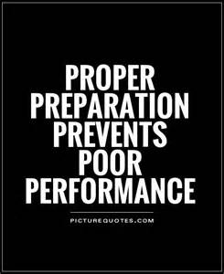


GCSE English Mr Osborne

GCSE English Language
100% Examination
Paper 1: Explorations in creative reading and writing
1 hour 45 minutes Section A: extract from fiction Section B: writing to describe/narrate
Paper 2: Writers’ viewpoints
1 hour 45 minutes
Section A: Two extracts (one pre 20th C)
Section B: Writing to argue/persuade.
Spoken Language as a separate endorsement.
GCSE English Literature
100% Examination
Paper 1: Shakespeare and pre 20th C 1 hour 45 minutes Section A: extract from Shakespeare Section B: extract from novel eg Dickens
Paper 2: Modern Text + Poetry. 2 hours 15 minutes Section A: Question from modern text Section B: Poetry question, comparison. Section C: unseen poetry

The Importance of English
- English Language is a core subject.
- Basic Literacy skills are essential to live!
- Being articulate is a wonderful asset.
- Most employers require GCSE English as a basic qualification.
- All colleges will now insist that students re-take English if students have not passed this exam in school.

A key subject – some linked careers:
Journalism
Publishing
Teaching
Administration
Civil Service
Advertising
Blogging

Useful Websites and Blogs

https://www.facebook.com/EnglishatOCS/
www.GCSEbite-size
http://mrbruff.com/
https://www.cliffsnotes.com/

GCSE Mathematics Mr A Gorman

There are two tiers of entry for GCSE Mathematics. Both tiers of entry are assessed through written examinations with no coursework. The examination board is OCR for all students.

The examination covers Number, Algebra, Geometry and Measures, Ratio/Proportion and Rates of Change, Probability and Statistics.

Higher tier allows for the awarding of grades 9-4 and Foundation tier allows for grades 5-1.

The students are taught from Year 10 in ability classes which are set based upon their assessments from Key Stage 3. It is possible for students to move sets in Years 10 and 11 if their performance merits this. Students will cover the same material in each class, but with a greater pace and rigour in the higher ability sets.

The decision to enter a student for either Higher or Foundation GCSE is taken after the mock exams in January of Year 11. Revision books and Maths Busters are available to purchase from the school office.

The most able students may also have an opportunity to cover and be entered for an AQA Level 2 Certificate in Further Mathematics or the FSMQ in Additional Maths. Both courses are designed to bridge the gap between GCSE and A-Level Mathematics.

Links

GCSE Maths - https://www.ocr.org.uk/qualifications/gcse/mathematics-j560-from-2015/
Further Maths - https://www.aqa.org.uk/subjects/mathematics/aqa-certificate/further-mathematics-8365/introduction
Additional Maths - OCR Level 3 FSMQ: Additional Maths Specification

Useful Websites and resources for revision

www.mrbartonmaths.com
www.mathsgenie.co.uk
CGP Revision Guides (www.cgpbooks.co.uk)
http://www.bbc.co.uk/education
https://www.khanacademy.org/
www.corbettmaths.com
www.mathswatch.co.uk

GCSE Sciences (AQA) Dr M Dixon

There are two pathways available in GCSE Science. Students must sit either Combined (Double) Science or Triple Science GCSEs. Good grades from either pathway will provide an excellent springboard for A-level Sciences. The vast majority of students have chosen to follow a traditional double science route comprising GCSE Combined Science - Trilogy (8464). It is called Trilogy because it comprises topics from the three distinct disciplines of Biology, Chemistry and Physics. A small number of students have opted to follow the Triple Science route and complete GCSEs in Biology (8461), Chemistry (8462) and Physics (8463).

Assessment

Whichever GCSE pathway students follow, they will sit two Biology, two Chemistry and two Physics examinations at the end of Year 11. Each GCSE Combined Science (Trilogy) examination is 1 hour and 15 minutes long whereas each of the GCSE Triple Science examinations are 1 hour and 45 minutes long.

Helping your child to succeed

- There is no shortcut to fulfilling potential: consistent hard work and practice are essential for students to achieve their best. A significant amount of homework will involve practice questions to help develop a secure knowledge of the curriculum.
- The school has purchased a subscription to Kerboodle. This gives students on-line access to the text-books as well as quizzes and animations at www.kerboodle.com All students will be expected to use this resource regularly to support their learning. Username – first initial then surname (all lowercase, no punctuation marks, some students may have a numeral added to distinguish them from other students with the same details). Password – initially the same as the username. Institution code – xdc6. Much of the homework set will require students to access Kerboodle, either to read and summarise information prior to a lesson or to complete assessments (as they already do with My Maths).
- Revision guides are available from the Finance Office (in Student Services) and can be purchased on-line for students to collect. Since we know that the best way to prepare for examinations is to practice exam questions we have selected revision guides with questions and question papers included (Combined Science Trilogy £9.20 and Triple Science guides £4.00 each – these prices are current at September 2020). Alternatives can be purchased but please make sure they are written for the correct exam board (AQA) and specification (codes 846-, see above).
- Online revision websites. These are numerous, but a particularly good one used extensively in school is Seneca, https://www.senecalearning.com/ .
Alternatives include http://www.bbc.co.uk/schools/gcsebitesize/ http://www.youtube.com/user/myGCSEscience, and www.s-cool.co.uk
- Encourage your child to build a portfolio of revision materials as they progress through the course to help structure their revision at the end. This might include mind maps and revision sheets which have been used to revise for tests and then the tests which have been reviewed and re-worked after completion.
- Practising and marking examination questions/papers is a good idea nearer to examinations. Some will be done in class, but there are some available on the AQA website: http://www.aqa.org.uk/exams-administration/exams-guidance/find-past-papers-and-mark-schemes .

Post-16 Information and Guidance Mrs Ludlam
(Director of Sixth Form Learning)
Mrs McQuiston
(Careers Co-ordinator)

The National Qualifications Framework helps learners to make informed decisions about the qualifications they need. They can compare the levels of different qualifications and identify clear progression routes for their chosen career.

It comprises nine levels (Entry level to level 8). Learners' progression routes do not necessarily need to involve qualifications at every level. Each accredited qualification has an NQF level. If qualifications share the same level this means that they are broadly similar in terms of the demand they place on the learner. However, qualifications at the same level can still be very different in terms of content and duration.

The following table shows a selection of individual qualifications and how they appear in the current NQF. It also highlights how qualifications broadly compare to the Framework for Higher Education Qualification (FHEQ) levels.

2 | - GCSEs grades 4-9 (old grades A*-C) | Level 2 VQs:  - BTEC awards, certificates and diplomas at level 2  - Functional Skills level 2
3 | - AS/A levels  - Advanced Extension Awards  - International Baccalaureate  - Key Skills level 3  - NVQs at level 3  - Cambridge International Awards  - Advanced and Progression Diploma | Level 3 VQs:  - BTEC awards, certificates and diplomas at level 3  - BTEC Nationals  - OCR Nationals |  | Framework for Higher Education  (Maintained by the Quality Assurance Agency)  Examples
4 | - NVQs at level 4  - Key Skills level 4  - Certificates of higher education | Original NQF Level 4* | Level 4 VQs:  - BTEC Professional Diplomas, Certificates and Awards |  | - Certificates of higher education
5 | - Higher national diplomas  - Other higher diplomas  - NVQs at level 4* | Original NQF Level 4* | Level 5 VQs:  - HNCs and HNDs  - BTEC Professional Diplomas, Certificates and Awards |  | - Diplomas of higher education and further education, foundation degrees and higher national diplomas
6 | - National Diploma in Professional Production Skills  - NVQs at level 4* | Original NQF Level 4* | Level 6 VQs:  -  - BTEC Advanced Professional Diplomas, Certificates and Awards |  | - Bachelor degrees, graduate certificates and diplomas
7 | - Postgraduate certificates and diplomas  - BTEC advanced professional awards, certificates and diplomas  - Fellowships and fellowship diplomas  - Diploma in Translation  - NVQs at level 5* | Original NQF Level 5* | Level 7 VQs:  - Advanced professional awards, certificates and diplomas |  | - Masters degrees, postgraduate certificates and diplomas
8 | - NVQs at level 5* | Original NQF Level 5* | Level 8 VQs:  - Award, certificate and diploma in strategic direction |  | - Doctorates

Learners can use the National Database of Accredited Qualifications to get up-to-date information on the current NQF level for all accredited qualifications. Both the current and previous levels are shown for qualifications in the higher levels of the NQF.

Post 16 Choices
The importance of a student's GCSE profile (i.e. the subjects and grades achieved at the end of Year 11) cannot be overstated. This profile is used to compare students on a nationwide basis for employment, training and higher education institutions despite the fact that students may have gone on to be successful in other courses
post-16 such as A Levels, BTEC etc.

Level 2 Qualifications (GCSEs, NVQs and BTECs First Diplomas)
- English
- Maths
- Science

How good do my GCSEs have to be?
- Certain degree destinations will require a specific GCSE profile e.g. Medicine will be looking for a high number of level 8/9s in a student’s results
- Oxford and Cambridge would also expect a high proportion of these top grades
- Progress in any field (Higher Ed or employment) is not possible without English Maths and Science at grade 4 or above

Level 3 Qualifications
- A1 is the first year of A Levels
- Think about your three subject combination, the most able can consider four subjects
- You will take all external exams at the end of year 2 of A Levels
- Discuss your aspirations with a specialist advisor to ensure you are studying the correct combinations
- A2 is the second year of A levels
- You can apply for university, apprenticeship or employment this year to begin in the following September
- All A Level exams are taken in the second year of study.

Apprenticeships and Training
- Apprenticeships are an excellent way of gaining qualifications and local workplace experience at post 16 or post 18.
- You work towards a work-based qualiﬁcation such as a National Vocational Qualiﬁcation (NVQ) and other nationally recognised qualiﬁcations.
- You receive a weekly/monthly wage and training from the employer
There are many levels of Apprenticeship, they can be started at a number of different points in your career.
Type of apprenticeship | Level | Equivalent educational level
Intermediate | 2 | 5 GCSE passes at grades 9-4
Advanced | 3 | 2 A level passes (grades A-E)
Higher | 4,5,6 and 7 | Foundation degree and above
Degree | 6 and 7 | Bachelor’s or Masters degree
Apprenticeships Sectors
- www.apprenticeships.org.uk
  - Agriculture, Horticulture and Animal Care
  - Arts, Media and Publishing
  - Business, Administration and Law
  - Construction, Planning and the Built Environment
  - Education and Training
  - Engineering and Manufacturing Technologies
  - Health, Public Services and Care
  - Information and Communication Technology
  - Leisure, Travel and Tourism
  - Retail and Commercial Enterprise
- Apprenticeships typically take between one and four years to complete, depending on the type of framework.
- There is no set time to complete an Apprenticeship
- There is no set rate of pay for apprentices, however a recent survey showed that the average wage per week for an apprentice is now around £250 and increases with developing experience.

Some useful links
- http://www.allaboutschoolleavers.co.uk/apprenticeship-advice
- https://www.unionlearn.org.uk/pay-apprentices
- https://www.gov.uk/apply-apprenticeship

Information and Guidance (IAG) at Oaklands

There are several sources of IAG at Oaklands.

You can request a Careers appointment with our two independent Careers Advisors from the Hampshire Futures for your son or daughter by contacting the Head of Year or tutor; alternatively students can “drop in” to the Careers Office in the Library and arrange a time.

Mrs McQuiston (Careers Leader) is also available during morning registrations and most lunchtimes in the Library area.

Mrs McQuiston Oaklands Careers Leader
Sue Hall & Spencer Chisham Hampshire Futures Careers advisors

Please use the following link for the Hampshire Futures website, (our careers advisers).
https://www.hants.gov.uk/educationandlearning/hampshirefutures/yourfuture

In addition, we use the following high quality careers platform:

A Complete Destinations Platform

Unifrog

In keeping with our commitment to provide students with outstanding careers guidance and tailored support when choosing their next step after school, we will now be using Unifrog; an award-winning, online careers platform. All students in Years 7, 8, 9, 10, 11, 12 and 13 will have access to this excellent website.

Unifrog brings into one place every undergraduate university course, apprenticeship, and college course in the UK, as well as other opportunities, such as School Leaver Programmes, MOOCs and every college at Oxford and Cambridge. This makes it easy for students to compare and choose the best university courses, apprenticeships or further education courses for them. They can also explore exciting opportunities further afield by looking at English taught undergraduate programmes available in Europe and the USA.

Additionally, the platform helps students successfully apply for these opportunities by writing their personal statement, applications and CVs and guiding them through the process, allowing teachers to give live feedback.

Students access the tool for the first time using a sign-up code which is unique to their form group. They then login using their email address and password and they can do so from any computer, tablet or smartphone. We would encourage you to use the platform with your child so you can support them through the process of deciding their next step.

For more information, go to www.unifrog.org or contact Mrs Ludlam in Sixth Form at Oaklands.

10 Tips for Building Resilience in
Children and Teens during Key Stage 4 Mrs Bonnington & Mrs Riddle

We all can develop resilience, and we can help our children develop it as well. It involves behaviours, thoughts and actions that can be learned over time. Following are tips to building resilience.

- Make connections
Teach your child how to make friends, including the skill of empathy, or feeling another's pain. Encourage your child to be a friend in order to get friends. Build a strong family network to support your child through his or her inevitable disappointments and hurts. Connecting with people provides social support and strengthens resilience.

- Help your child by having him or her help others
Children who may feel helpless can be empowered by helping others. Engage your child in age-appropriate volunteer work, or ask for assistance yourself with some task that he or she can master.

- Maintain a daily routine
Sticking to a routine can be comforting to children, especially younger children who crave structure in their lives. Encourage your child to develop his or her own routines.

- Take a break
While it is important to stick to routines, endlessly worrying can be counter-productive. Teach your child how to focus on something besides what's worrying him or her. Be aware of what your child is exposed to that can be troubling, whether it be news, the Internet, overheard conversations, and make sure your child takes a break from those things if they trouble him / her.

- Teach your child self-care
Make yourself a good example, and teach your child the importance of making time to eat properly, exercise and rest. Make sure your child has time to have fun, and make sure that your child hasn't scheduled every moment of his or her life with no "down time" to relax. Caring for oneself and even having fun will help your child stay balanced and better deal with stressful times.

- Move toward your goals
Teach your child to set reasonable goals and then to move toward them one step at a time. Moving toward that goal - even if it's a tiny step - and receiving praise for doing so will focus your child on what he or she has accomplished rather than on what hasn't been accomplished, and can help build the resilience to move forward in the face of challenges.

- Nurture a positive self-view
Help your child remember ways that he or she has successfully handled hardships in the past and then help him understand that these past challenges help him build the strength to handle future challenges. Help your child learn to trust himself to solve problems and make appropriate decisions. Teach your child to see the humour in life, and the ability to laugh at one's self.

- Keep things in perspective and maintain a hopeful outlook
Even when your child is facing very painful events, help him look at the situation in a broader context and keep a long-term perspective. Although your child may find it hard to consider a long-term look on his own, help him or her see that there is a future beyond the current situation and that the future can be good. An optimistic and positive outlook enables your child to see the good things in life and keep going even in the hardest times.

- Look for opportunities for self-discovery
Tough times are often the times when children learn the most about themselves. Help your child take a look at how whatever he / she is facing can teach him "what he / she is made of."

- Accept that change is part of living
Change often can be scary for children and teens. Help your child see that change is part of life and new goals can replace goals that have become unattainable.

Useful Revision Websites

Seneca: Free Homework & Revision for A Level, GCSE, KS3 & KS2 (senecalearning.com)
Kerboodle: Kerboodle
Mathswatch: MathsWatch
Physics and Maths Tutor: Physics & Maths Tutor (physicsandmathstutor.com)
Studywise: GCSE Revision - StudyWise
Revision world: Revision World - Free GCSE & A-Level Revision Resources
GCSE BBC Bitesize: GCSE - BBC Bitesize
Memrise: Memrise
Adapt: Adapt - free Revision Timetable App for A-level & GCSE (getadapt.co.uk)
Get Revising: Get Revising

Some useful websites for parents

http://youth.anxietybc.com/
http://www.familylives.org.uk/
http://www.triplep-parenting.uk.net/uk-en/triple-p/?cdsid=ujfjnrjlspimtqktljnfkorlinlffjfk
http://apps.nhs.uk/app/sam-self-help-for-anxiety-management/
https://www.thinkpacifica.com/
http://www.youngminds.org.uk/

Mindfulness is an effective way to help alleviate anxiety. The following link has useful information and exercises for your child if they are experiencing both general and/or exam anxiety. Adult colouring books are also a great way to encourage young people to concentrate and focus on the present moment encouraging good emotional wellbeing.

http://youth.anxietybc.com/mindfulness-exercises

www.parentlineplus.org.uk
www.beatbullying.org
www.bullying.co.uk
www.kidscape.org.uk

Dealing with Teenage Stress

www.aware.ie includes useful tips on dealing with depression
www.winddown.co.uk/Teen-Stress.html general website about stress with some info on teen stress
www.getconnected.co.uk is a free help/counselling site for teenagers. They can also be called on 08088084994.
www.yourteenager.co.uk is a general help website for parents of teenagers, with lots of tips for coping with teen stress
www.samaritans.org

There is a parent section on the Oaklands website and relevant and topical posts are added including articles on eg mental health, eating disorders, mindfulness etc.

Mental Health Support: - Some useful organisations, websites and apps include:
Kooth: Home - Kooth
Off The Record: Off The Record (South East Hampshire) (otr-south.org.uk)
Young Minds: YoungMinds | Mental Health Charity For Children And Young People | YoungMinds
Headspace: Meditation and Sleep Made Simple - Headspace
Teen yoga: Teen Yoga Foundation - TeenYoga

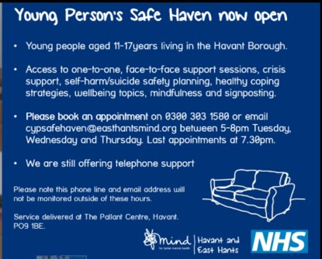

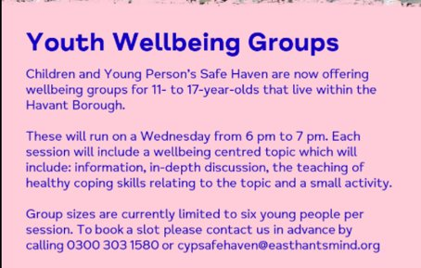

Cybersafety – Lee Haywood, Online Safety UK

Our children live increasing connected and global lives- it's important to remember that this is often a very positive and inspiring thing- but we all need to be alert to the dangers and signs to look for around your child's online behaviour.

Remember- the old “stranger danger” rules still apply, but it’s more important than ever to keep an open dialogue with your child in order to help them feel safe and present themselves in a positive light online. Further resources for support are:
www.onlinesafetyuk.com
www.thinkuknow.co.uk
http://www.nspcc.org.uk/preventing-abuse/keeping-children-safe/online-safety/
www.kidpower.org/
www.netmums.com/teenagers/safe-surfing-on-the-internet
http://ceop.police.uk/

