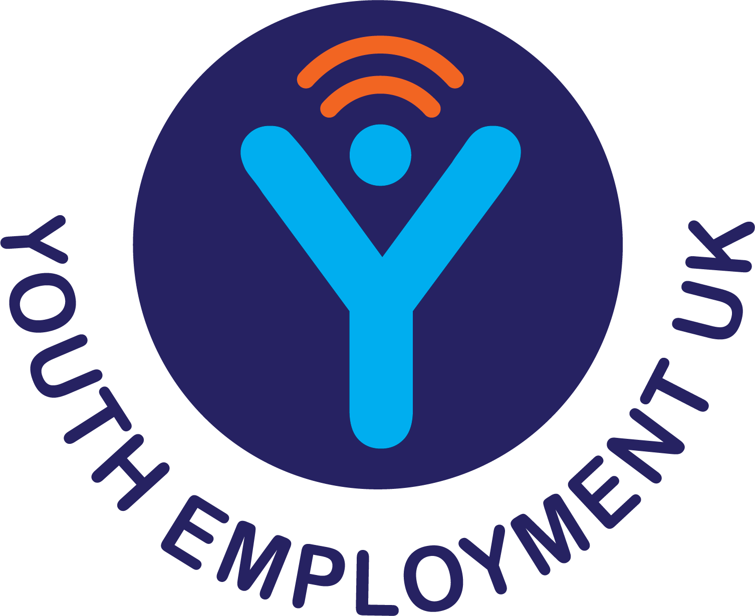

#CreateYourFuture



This week’s theme is Knowing your Choices and you’ll take part in activities from Youth Employment UK’s online Young Professional programmes and explore extra resources and opportunities to build you knowledge and understanding.

The activities that we will cover this week include:

- Exploration of the range of pathways available to them including: vocational and academic pathways, starting a business and finding employment.
- Considering the differences between some of the options.
- Exploring how to make decisions about future options, good questions to ask and where to go for additional support and information.

To get started, take a look here at Week 2 intro + activities list

Then have a go at Week 2 Young Professional Activity

