#CreateYourFuture

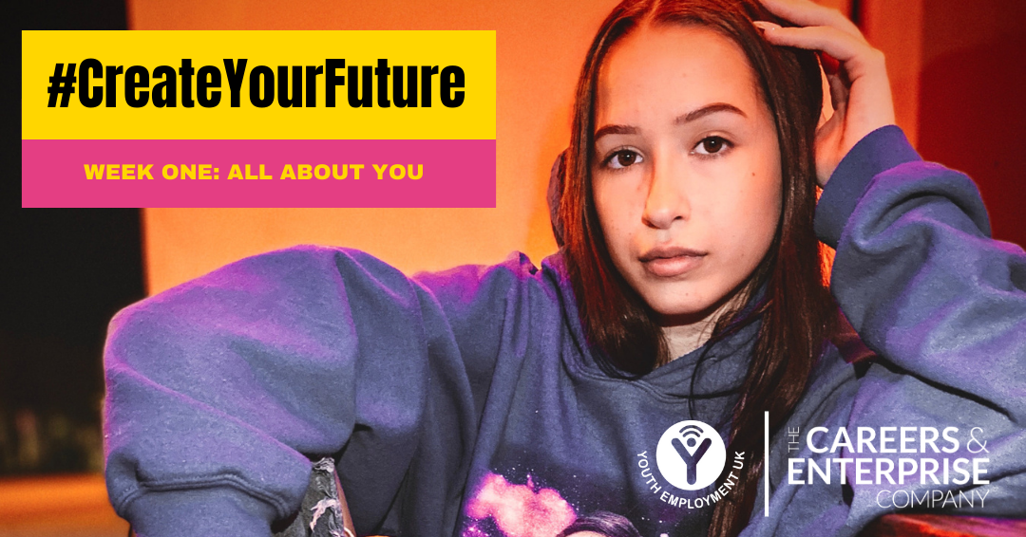

This week’s theme is You and Your Needs and you’ll take part in activities from Youth Employment UK’s online Young Professional programmes and explore extra resources and opportunities to build you knowledge and understanding.

The activities that we will cover this week include:

- Considering your strengths, weaknesses, opportunities and threats.
- Exploring where you are today, your barriers, where you could be and where to get help.
- Understanding how to take better care of your emotional wellbeing feel more confident in decision making and goal setting.

To get started, take a look here at Week 1 intro + activities list

Then have a go at Week 1 Young Professional Activity

