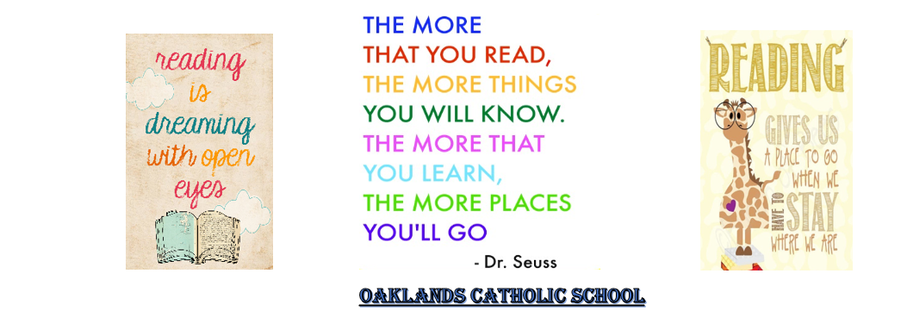
PLEASE NOTE THAT PARENTAL GUIDANCE IS ALWAYS ADVISED BEFORE YOUR CHILD STARTS READING A NEW BOOK.

Top 10 Teen Books
1. The Hunger Games by Suzanne Collins
2. The Fault in Our Stars by John Green
3. To Kill a Mockingbird by Harper Lee
4. Harry Potter series by JK Rowling
5. 1984 by George Orwell
6. The Diary of a Young Girl by Anne Frank
7. A Streetcat Named Bob by James Bowen
8. The Lord of the Rings by JRR Tolkien
9. The Perks of Being a Wallflower by Stephen Chbosky
10. Jane Eyre by Charlotte Brontë

The Guardian’s Top 50 books that will …
Teach you about love:
The Diary of a Young Girl by Anne Frank
Pride and Prejudice by Jane Austen
Forever by Judy Blume
Twilight by Stephenie Meyer
How I Live Now by Meg Rosoff
Wuthering Heights by Emily Brontë
Jane Eyre by Charlotte Brontë
Thrill you:
The Hunger Games by Suzanne Collins
The Mortal Instruments: City of Bones by Cassandra Clare
Divergent by Veronica Roth
Gone by Michael Grant
Rebecca by Daphne du Maurier
Skulduggery Pleasant by Derek Landy
A Clockwork Orange by Anthony Burgess
Transport you:
Harry Potter series by JK Rowling
The Lord of the Rings by JRR Tolkien
Percy Jackson series by Rick Riordan
Life of Pi by Yann Martel
Northern Lights by Philip Pullman
The Great Gatsby by F Scott Fitzgerald
Change the way you think
To Kill a Mockingbird by Harper Lee
A Streetcat Named Bob by James Bowen
The Book Thief by Markus Zusak
Noughts and Crosses by Malorie Blackman
Wonder by RJ Palacio
The Curious Incident of the Dog in the Night-timeby Mark Haddon
The Perks of Being A Wallflower by Stephen Chbosky
Help you to understand you
The Fault in Our Stars by John Green
The Catcher in the Rye by JD Salinger
The Knife of Never Letting Go by Patrick Ness
I Capture the Castle by Dodie Smith
The Outsiders by SE Hinton
Make you cry
The Color Purple by Alice Walker
Of Mice and Men by John Steinbeck
The Time Traveler's Wife by Audrey Niffenegger
The Kite Runner by Khaled Hosseini
War Horse by Michael Morpurgo
Before I Die by Jenny Downham
My Sister's Keeper by Jodi Picoult
Make you laugh
Catch 22 by Joseph Heller
The Hitchhiker's Guide to the Galaxy by Douglas Adams
The Secret Diary of Adrian Mole Aged 13¾ by Sue Townsend
Geek Girl by Holly Smale
Diary of a Wimpy Kid by Jeff Kinney
Angus, Thongs and Full-frontal Snogging by Louise Rennison
Scare you
1984 by George Orwell
Lord Loss by Darren Shan
The Rats by James Herbert
The Shining by Stephen King
The Wasp Factory by Iain Banks
Teach you about love
The Diary of a Young Girl by Anne Frank
Pride and Prejudice by Jane Austen
Forever by Judy Blume
Twilight by Stephenie Meyer
How I Live Now by Meg Rosoff
Wuthering Heights by Emily Brontë
Jane Eyre by Charlotte Brontë

