The best young adult books.
Y10, 11 AND SIXTH FORM Only.

N.B: some YA books deal with particularly serious issues/mature themes; please ensure that you are happy for your son/daughter to read a certain book beforehand.

REFERENCE:
http://www.telegraph.co.uk/books/young-adult-books/best-of-2015/
Reviews by Martin Chilton (and Rebecca Hawkes, where stated). The list is in no particular order.

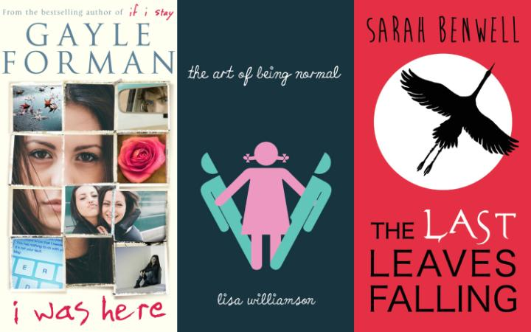

1. THE ART OF BEING NORMAL BY LISA WILLIAMSON (DAVID FICKLING BOOKS)
Lisa Williamson's debut YA novel The Art of Being Normal is a powerful tale of a transgender teenager's struggle with identity. Although the prejudice the characters face is depressing – and we see how easy it is to make assumptions about what is a "typical" boy or girl – there is hope, not least in the love and understanding that some of the friends and family members display. Review by Martin Chilton
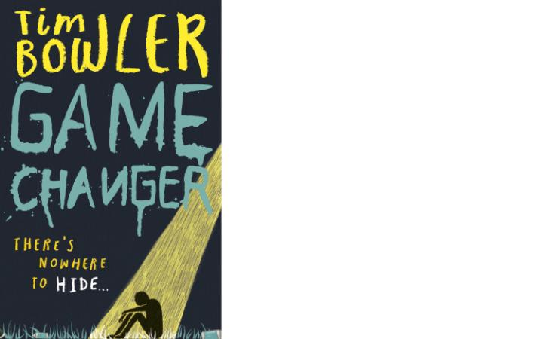
See full review of The Art of Being Normal
2. GAME CHANGER BY TIM BOWLER (OXFORD UNIVERSITY PRESS)
"Let's make it a school day, Mickey."
"Rather than a wardrobe day."
"Exactly"
That's just one small example of the moving dialogue between 15-year-old Mickey, the protagonist of Tim Bowler's new YA novel, and his younger sister Maggie. We all have days when we feel like hiding in a wardrobe but Mickey (Michael Molyneux) has them all the time. The novel could be totally bleak - "No root cause, no trigger. You're born terrified, you live terrified, you probably die terrified." – Mickey says. That it's not is down to the wonderful way that sister and brother do what they should do: help each other through the worst of things. There is also an engaging humour to the protagonist (he dismisses his shrink for talking "big crazy b-----s") an unusual and interesting boy who finds solace in reading Moby Dick and Charles Dickens. When Mikey feels ready to face the world outside, something goes horribly wrong and he witnesses a savage crime. The gang knows where he lives. What happens next is gripping and scary. The depiction of Mickey is shrewd and tender and it makes an interesting counterpoint to the melodrama that follows. Although it's a short novel, it's powerful and exciting and contains scenes as claustrophobic as Mickey's small wardrobe." MC
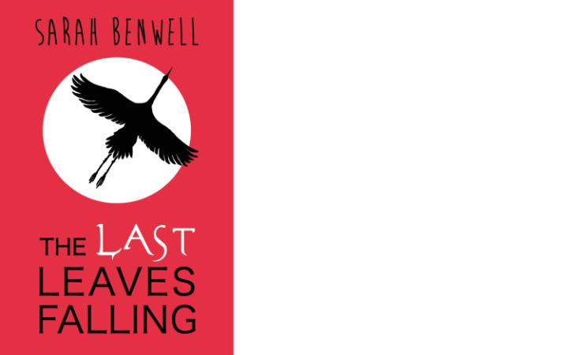
3. THE LAST LEAVES FALLING BY SARAH BENWELL (RANDOM HOUSE)
In her debut YA novel, Sarah Benwell follows Japanese teenager, Sora, as he comes to terms with a diagnosis of the terrible Lou Gehrig disease (the medical name is Amyotrophic Lateral Sclerosis). "I have an old man's disease," says Sora. The Last Leaves Falling is a complex book that tells the story through a mixture of recollections, website message boards, text messages, emojis and old-fashioned letters. We feel the pain as we see what this fatal illness means for the boy and for those he loves. The story, set in an accessible modern Japan, is about life and death. It's also about the power of friendship and connection. MC
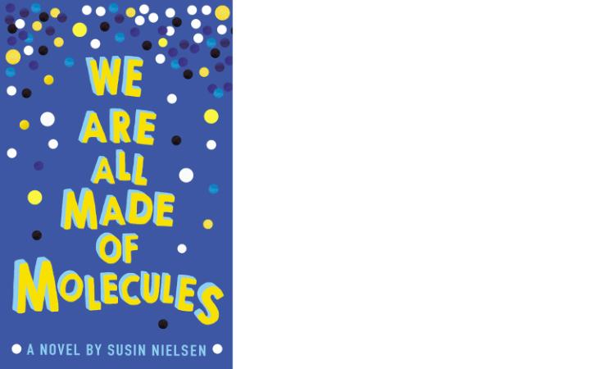
4. SUSIN NIELSEN: WE ARE ALL MADE OF MOLECULES (ANDERSEN PRESS)
Teenagers Stewart and Ashley are thrown together when their parents fall in love. Ashley is the super cool and popular girl who dismisses her new de facto step-brother as "the freakazoid", with the insult that he's so short "I wanted to offer him a booster seat". He's gifted, possibly on the spectrum, and utterly charming. And smart. "Yes, he really said plethora," says Ashley. "What kid says plethora? And what does plethora even mean?" What he lacks are social skills. And a mum. She has died of cancer. Will her "vibe" find its way to their new home, he wonders in a very touching paragraph. Ashley, so shallow and mean, is only worried that people will find out that her father is gay. Nielsen, a former television writer, keeps the dialogue snappy and witty and We Are All Made of Molecules explores some big themes such as bullying, grief, death and homophobia in a warm and witty way. And Jared, the school bully, is convincingly sly and sordid. A really fine YA novel. MC
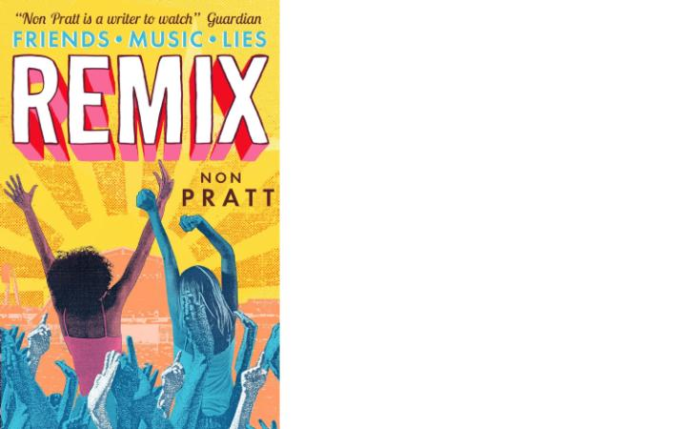
5. NON PRATT: REMIX (WALKER BOOKS)
Kaz and Ruby are teenagers, best friends and both struggling with recent break-ups. Everything comes to the fore, in a heady emotional mix, when they head to a summer music festival. I enjoyed Non Pratt's debut, Trouble, and Remix is even better. The protagonists, who alternate telling the story, have their own distinct characters and engaging dialogue. Pratt conjures up the insecurity and intensity of being young and away at a festival (even one with a Mellow Tent) and builds the tension well. So what happens when teens are let loose at a music festival? You'll have to read Remix to find the key to that. The novel is moving and a fun summer read. MC
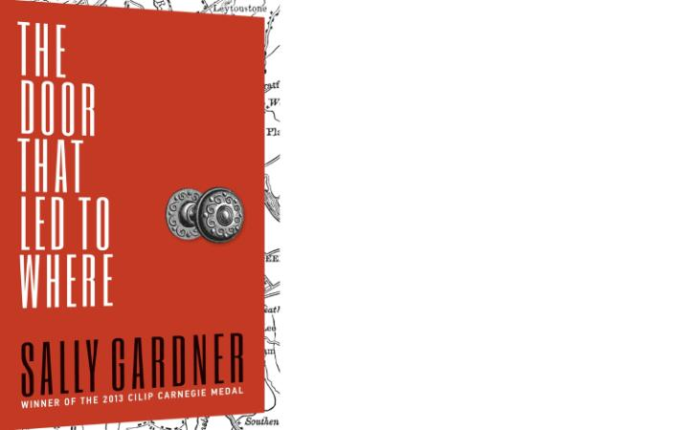
6. THE DOOR THAT LED TO WHERE BY SALLY GARDNER (HOTKEYBOOKS)
Award-winning Sally Gardner has written a complex and gripping historical mystery thriller, which has a lot to say about the values of London then (1830) and now. MC
See full review of The Door That Led to Where
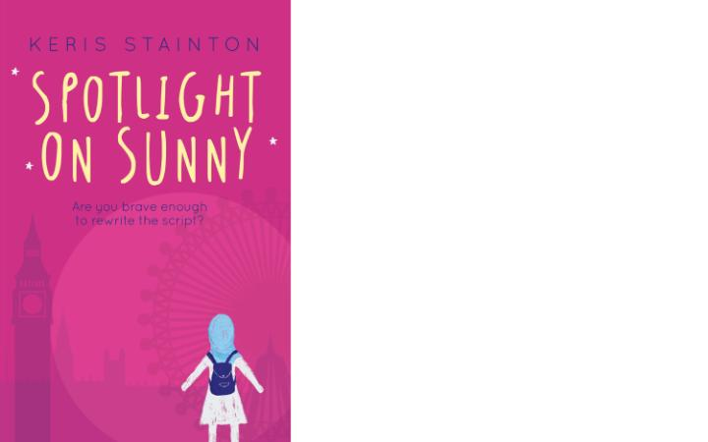
7. KERIS STAINTON: SPOTLIGHT ON SUNNY (CATNIP PUBLISHING)
"I just don't like it when people make assumptions," says Sunny, the 14-year-old protagonist of the second book in Keris Stainton's Reel Friends series. Sunny is a Muslim, who prays, wears a ḥijāb and is not interested in a casual boyfriend. In this follow-up to the impressive Starring Kitty, Stainton takes Sunny and her best friends Kitty and Hannah to London for a film-making course. They are all out of their comfort zones, geographically and mentally, and have to deal with the assumptions people make about them ("really you have to keep coming out for your whole life," says Kitty). Sunny is a warm and a well adjusted teenager, whose character provides an understated insight into the life of Muslim teens in Britain, something important given negative stereotypes. Seeing Sunny start to figure out what she wants from life (and blossom during her London adventure) is a strength of a novel possibly aimed at the younger end of the YA market. As ever, Stainton advocates diversity and self-awareness in a subtle way. And Tim Rose's cover design is neat. MC
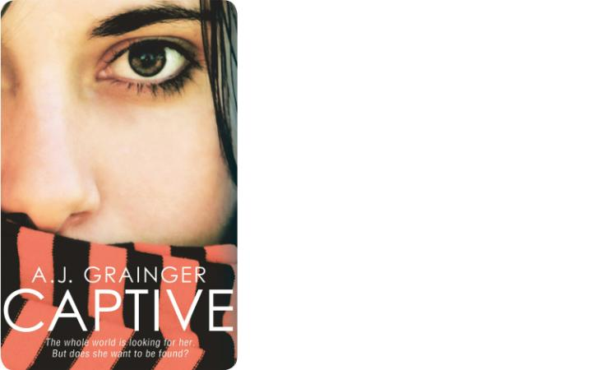
8. CAPTIVE BY AJ GRAINGER (SIMON AND SCHUSTER)
There is a grim reality to Captive, the debut YA thriller by AJ Grainger, partly because it involves a terrorist (eco-terrorist) incident in Paris, where there is an assassination attempt on the British Prime Minister. Back in London, some time later, the same group manage to kidnap his 16-year-old daughter Robyn Elizabeth Knollys-Green, who tells the story of how this drama unfolds. Some of the best moments are when we are shown Robyn's sense of bewilderment at her tricky family life and having to live in the public eye. The drama is initially taut (after she is kidnapped) but begins to stretch credibility, and there is a sense that the story is striving too hard for the "cinematic" drama marketed in the promotional blurb. The saddest message of the book, however, is when Robyn says: "The world is not safe. I know that now and I can't unknow it." MC
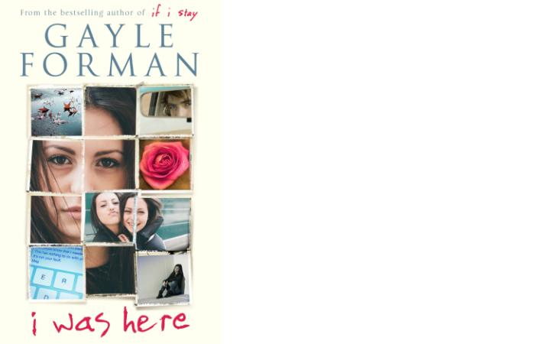
9. I WAS HERE BY GAYLE FORMAN (SIMON AND SCHUSTER)
The suicide of a young girl is obviously one of the most sensitive topics you could tackle and Gayle Forman, the 44-year-old American, is clearly conscious of that in the way she deals sympathetically with the impact of such a tragic event in her mystery/thriller YA novel I was Here. The opening sections of the book, in which we are shown Cody's reaction to the death of her best friend Meg, are the strongest. It's a mystery story, with some snappy dialogue, but hampered by a few too many clichés. MC
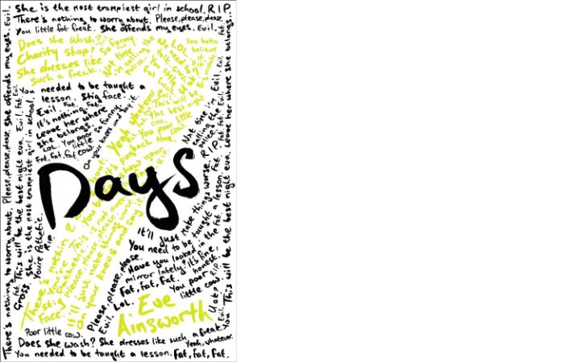
10. SEVEN DAYS BY EVE AINSWORTH (SCHOLASTIC)
Life at home is miserable for Jess since her father left. School is even worse. She is tormented by a girl called Kez, for being fat and scruffy (they call her The Stig). What makes the book interesting is that we see the bullying from both sides and see that Kez has her problems too, particularly with a violent father. It is a gritty and painful tale - "people always find a weakness," - but ultimately one of redemption, even if it is all wrapped up a little too neatly (in seven days). But the characters are strong and the message important. MC
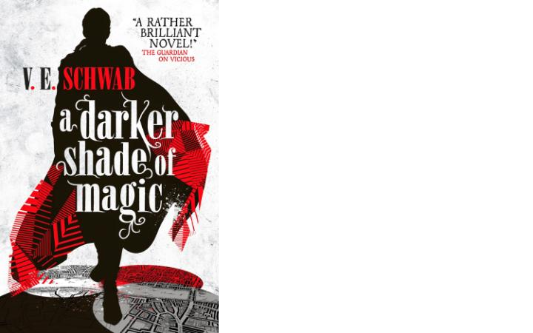
11. A DARKER SHADE OF MAGIC BY VE SCHWAB (TITAN BOOKS)
Fans of fantasy (adults and young adults) will enjoy A Darker Shade of Magic, the new novel from Victoria 'VE' Schwab. Unusually for YA it has a male lead – the confident magic man Kell, with his jet black eyeballs – in an action-packed adventure ranging across four different Londons. Grey, Red, White and Black. The depictions of the dirty and crowded Grey London (home to King George III) are particularly strong. MC
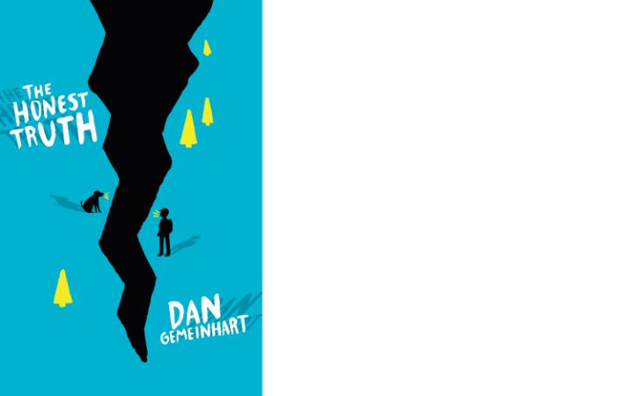
12. THE HONEST TRUTH BY DAN GEMEINHART (CHICKEN HOUSE)
Mark, who is 12, has cancer and can't stand the pain any longer and the story is about what happens when he disappears with his rather likeable dog Beau. The story is told in alternating first-person voices, by Mark and his friend Jessie. It's not an innovative novel but is a gripping enough story to entertain the younger end of the young adult market. MC
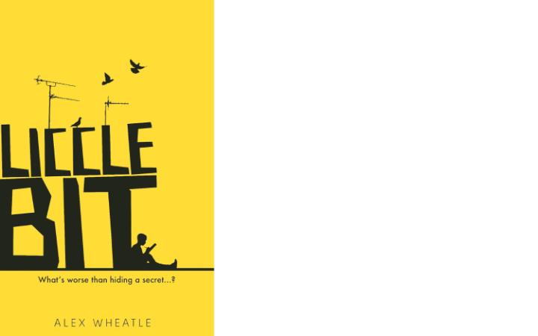
13. LICCLE BIT BY ALEX WHEATLE (ATOM BOOKS)
"Some girl called me Liccle Bit in Year 7 and it stuck," says 14-year-old Lemar, the protagonist of Alex Wheatle's debut YA novel. The humour is strong and edgy. A boy called McKay teases Liccle Bit about his "Oompa-Loompa height and slavery days haircut". Someone overweight is called a "fat salad-hater". The novel shows how easy it is for an inner-city youngster to get drawn into a bad situation. Manjaro, who manipulated Lemar, is a menacing gang figure. Although the parts about a turf war on an estate are very bleak (victims of killings are referred to as having been "deleted" or "blazed") the book does contain strong messages about love and loyalty. And hats off to designer Sophie Burdess and illustrator Dan Evans for an arresting front cover. MC
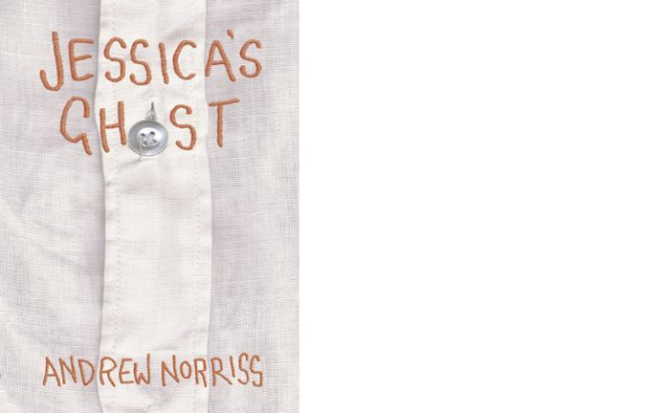
14. JESSICA'S GHOST BY ANDREW NORRISS (DAVID FICKLING BOOKS)
James Stewart's famous cowboy loner in Winchester '73 says that his father told him that "if a man had one friend, he was rich". Friendship is at the heart of Jessica's Ghost, although the friend to Francis Meredith, himself a loner, happens to be a ghost called Jessica Fry. They even bond over a shared love of synthetic fabrics and fashion. Jessica seems to be there to help Francis, a boy who is bullied and suffering depression, and his collection of odd and amiable new friends: the ones who can actually see and hear Jessica. In this funny and moving tale, Whitbread-winning author Andrew Norriss deals with some tricky subjects, including mental health and suicide. There is a moment of Patrick Swayze-Demi Moore cliché but overall this is a good read for young teenagers and Francis certainly feels rich with Jessica as a friend. MC
15. JEKYLL'S MIRROR BY WILLIAM HUSSEY (OXFORD UNIVERSITY PRESS)
Comedian Dylan Moran wrote recently about the impact of the 24-hour digital world. "This permanent illuminated shop window, the horror of now," he called it. William Hussey's supernatural YA horror story Jekyll's Mirror takes Robert Louis Stevenson's 1886 novel Jekyll and Hyde as its theme and brings personality distortion into a 21st-century setting - by way of modern social media. Sam Stillhouse is one of the maladjusted teens recruited by English teacher Miss Crail to take part in 'Project Hyde', to interact online with a series of avatars and get involved with trolling. At first he is fascinated by the project: a social networking site where you are urged to anonymously speak your mind about people. But the more time he spends on the site, the nastier he gets. The site becomes a dangerous outlet for all the anger (which he calls the Wrath) buried inside himself since the murder of his mother. The consequences are a cautionary tale.
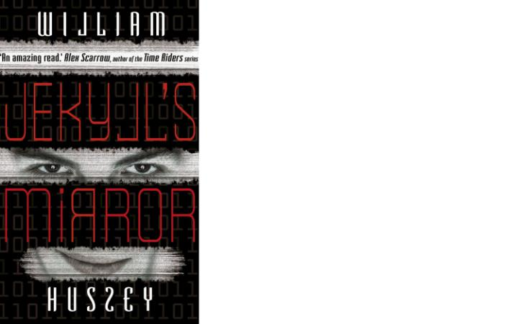
Jekyll's Mirror is a pacy read which has important things to say about cyberbullying and the stresses and strains facing youngsters in this permanently illuminated modern world. MC

16. SAM HEPBURN: IF YOU WERE ME (CHICKEN HOUSE)
A contemporary thriller about two teenagers from different backgrounds teaming up to solve a mystery. Dan's father is a London-based plumber and Aliya has fled to England from Afghanistan to escape the Taliban. When Dan witnesses Aliya’s brother Behrouz being beaten and kidnapped and falsely accused of terrorism he has to decide whether to help Aliya. There are gripping scenes in the novel although the extent of the web of corruption does start to feel a little overcooked. MC
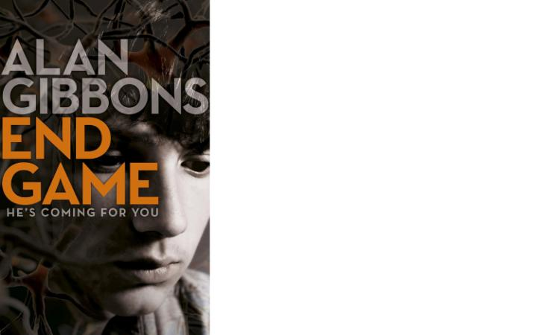
17. ALAN GIBBONS: END GAME (INDIGO)
Nick Mallory, 17, is lying in a hospital bed after a horrific car crash. His mum is by his bedside along with his father, a politician and former soldier. "Why does the thought of calling this man Dad stick in my throat?" NIck wonders.He can't speak or move. Only his 13-year-old sister Saffi believes her brother can hear and understand every word being spoken. This is the start of a gripping mystery thriller, which examines the problems and dangers of trying to understand the past and your own family. The intrigue builds well and there are also flashes of wit. When Nick hears his Grandad grunt and mumble "chin up", he says to himself: "ah, great, now I'm part of a war film." Another winner from the reliable Gibbons. MC
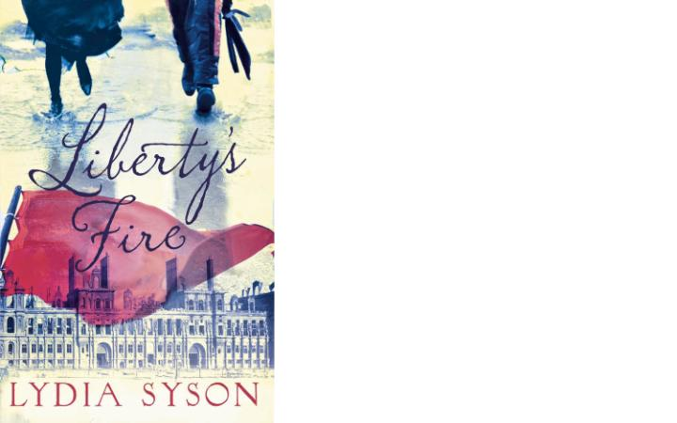
18. LYDIA SYSON: LIBERTY'S FIRE (HOT KEY BOOKS)
Tens of thousands died and Paris was left "a stinking, smouldering ruin" by the events of the Paris Commune in 1871 and the bloody uprising. Lydia Syson does another fine job of bringing to life sometimes neglected periods of the past (the detail is great, even taking in bears made to wear boxing gloves and fight) in this historical YA romance featuring Anatole, a young violinist at the Théâtre Lyrique, and Zéphyrine. MC
19. SARAH PINBOROUGH: THE DEATH HOUSE (ORION)
Many YA books thrive on conspiracy. There’s often a mystery to be uncovered, or a shadowy authority to outwit and overturn. In some ways, Death House by Sarah Pinborough (the author has also written fantasy fiction under the name Sarah Silverwood) is no exception. The book centres on a ragtag community of teens – mostly boys but a few girls – who are held on an island, guarded by nurses, teachers and a forbidding Matron. All have been told that they are “defective”: sooner or later, one by one, they will sicken, and be taken to the sanatorium, where an unspecified horrific “change” and eventual death awaits.
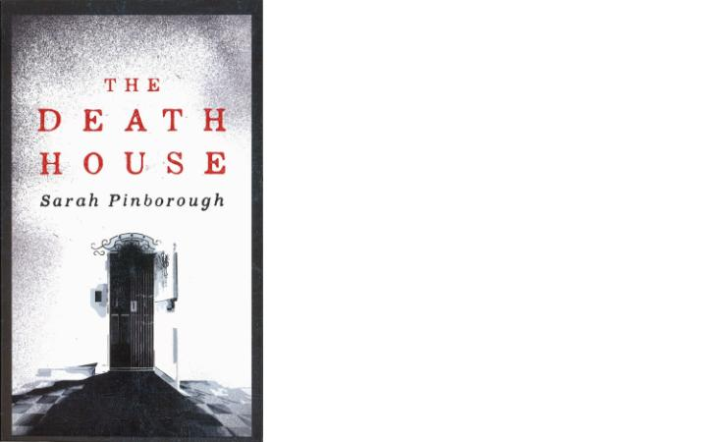
However, where Pinborough’s novel differs from more conventional fare, is in the fact that the book ultimately isn’t a story about defeating those in power, or overturning the status quo. Instead, as 16-year-old protagonist Toby falls for newcomer Clara, it becomes a love story (albeit a very sad one). By the end of the book, the characters are virtually none the wiser about what is happening to them; the official balance of power and the cruelty remain unchallenged. But, despite this, the story manages to be a strangely hopeful one. In a world where death is everywhere, every breath, and every heartbeat becomes precious. Pinborough’s vivid writing ensures her readers feel every one.
Review by Rebecca Hawkes

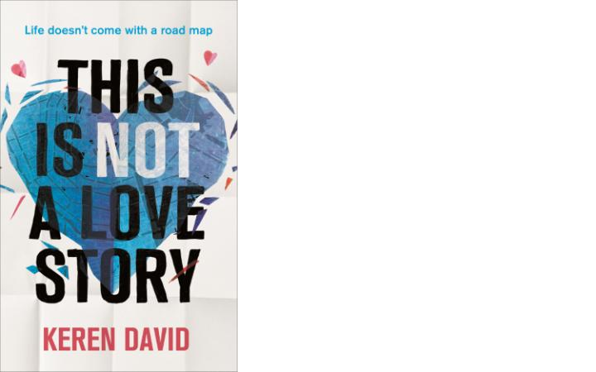
20. KEREN DAVID: THIS IS NOT A LOVE STORY (ATOM BOOKS)
A very modern tale of adolescent love and identity (there is even a Fifty Shades joke on the opening page) This Is Not a Love Story deals with identity, sexuality, racism and relationships. It's set in Amsterdam and London and the main characters are strong. Kitty, whose father has died tragically early having a heart attack while watching Spurs score in a Cup Final (the joke is too obvious to make) falls in love with both Ethan (who is bisexual) and Theo. "If Ethan had been an animal, he'd have been something wild and untamed, like a wolf. Theo was more of a Labrador." Both 16-year-olds harbour their own secrets, which the boook slowly reveals.The humour is good (Keren David is funny on the resemblance of the London Jewish community to the 19th-century aristocracy) and the complexities and confusion of life for teenagers is brought to life well in a novel told from both Kitty and Theo's perspectives. MC
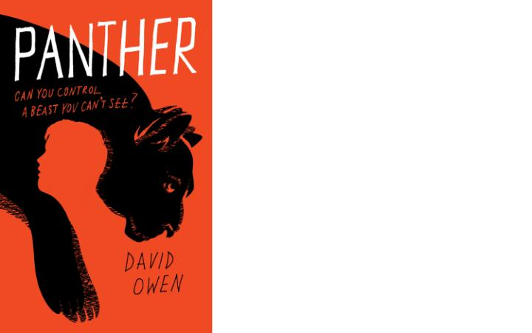
21. DAVID OWEN: PANTHER (CORSAIR)
At a time when the Child and Adolescent Mental Health Service is under strain and in desperate need for government funding, David Owen's debut novel, Panther, is a timely YA novel. Panther is a powerful and unsentimental look at depression for youngsters. We see it through the eyes of Derrick, whose sister is struggling with mental health issues. Derrick is desperate to get out of the house, "trying to escape the darkness that threatened to choke him inside its walls". Derrick has his own problems. He's overweight and starts to binge eat when his only friend has rejected and he's fallen for a girl who isn't interested in him. When the local South London newspapers report that a panther is on the loose in his South London area, Derrick starts to believe that capturing and taming the panther ( a metaphor for all this turmoil) could solve all his troubles. I won't spoil the ending but it's interesting that Derrick is never a completely reliable narrator and the issue of mental health is dealt with in a candid and deft way. MC
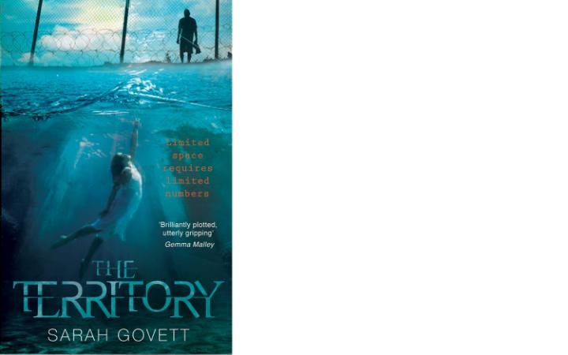
22. SARAH GOVETT: THE TERRITORY (FIREFLY PRESS)
Old Britain is a mess. Parts are flooded completely and are known as the Wetlands. You don't want to end up in the Wetlands (84 per cent of people sent there die of malaria). The richest live in the Territory and have a node on their neck through which they can download information. Some people are robotic losers, freakoids. The so-called Norms are caught in a world of vicious competition. "People don't actually care that much about improving the lives of people they don't know. Humans are rubbish," the book says. But as well as a pacy distopian fantasy thriller (the first in a triolgy) this is also a love story, with 15-year-old Noa Blake torn between Jack and Raf. MC

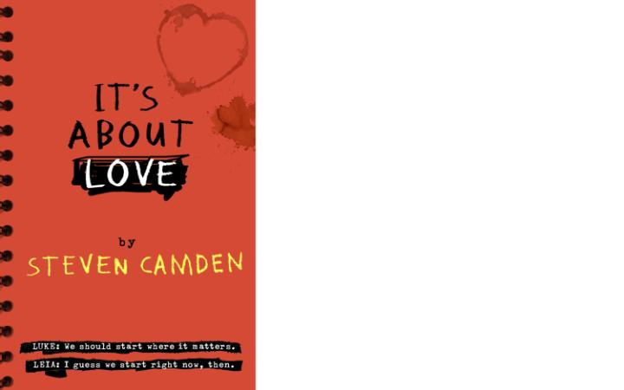
23. STEVEN CAMDEN: IT'S ABOUT LOVE (HARPER COLLINS CHILDREN'S BOOKS)
Cracking dialogue is at the heart of the success of It's About Love, the second YA novel from Steven Camden, the spoken-word poet who performs as Polarbear. The book revolves around teenagers Luke and Leia (come on, you don't need me to reference that), who are on the same film studies course. They are terrific characters.
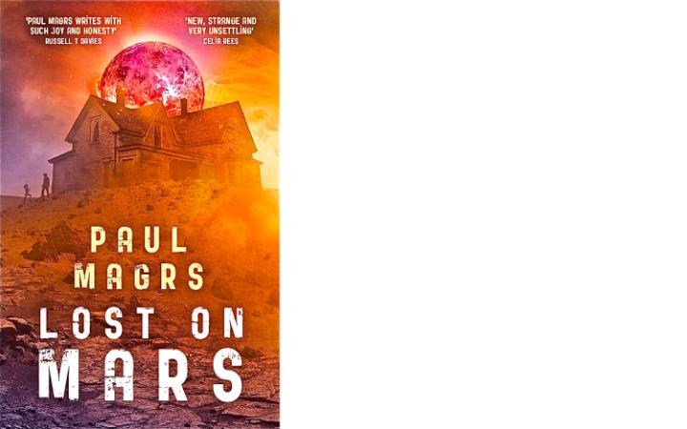
There's humour, especially in the portrayal of oily fellow student Simeon ("he looks like he should be in a toothpaste advert"), and zippy movie references throughout. It's About Love is also about identity, self-worth and background (you can't escape where you have come from). Camden, author of the moving debut novel Tape, pulls it all together in a thought-provoking and entertaining novel. Although it's pacy, it's a reflective book, too, as when Luke says of his father: "I try to picture him at my age, nearly seventeen and unsure of himself, or scared, or confused or even slightly nervous, but I can't. Dad's emotions only seem to do the primary colours, happy, sad or angry. I know that can't be true, all the other shades must live underneath his skin." MC
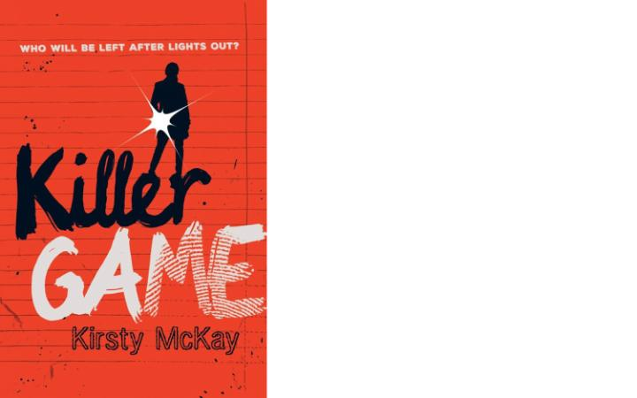
24. PAUL MAGRS: LOST ON MARS (FIREFLY PRESS)
You can see that Paul Magrs, the author of several Doctor Who books, is comfortable writing about a vivid extraterrestrial setting, and this gripping sci-fi thriller is set on a futuristic Mars. The story is bold and you have to love a chapter that opens with the words: "It was late in our Martian autumn when we were allowed to hold the funeral for Grandma's leg." Lora, stubborn and complex, is at the heart of this first part of a trilogy about third-generation settlers on the desolate red planet. There's also a likeable and talkative robot called Toaster. It's also a novel about alienation. But watch out for the Martian flesh-eaters. MC
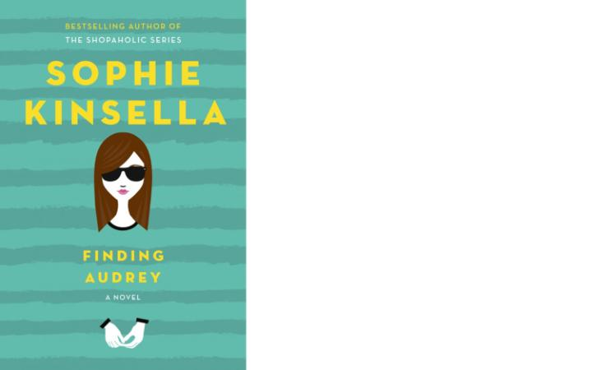
25. SOPHIE KINSELLA: FINDING AUDREY (DOUBLEDAY)
Finding Audrey is the first YA novel from Sophie Kinsella, the author of the bestselling Shopaholic series. Audrey, 14, rarely leaves home and usually wears dark glasses. She has anxiety disorders coupled with bouts of depression. She is seeing a therapist called Dr Sarah, but things really change when she meets Linus, her brother’s gaming team-mate. We discover what's behind Audrey's condition and along the way there is plenty of snappy dialogue and light-touch family comedy, especially between Audrey and her mum. "Mum's social life is practically non-existent," says Audrey. "So when she goes out, she makes up for it with perfume, eye-liner, hairspray and heels. As she totters down the stairs, I can see a little fake-tan blotch on the back of her arm, but I won't tell her. Not on her birthday." MC
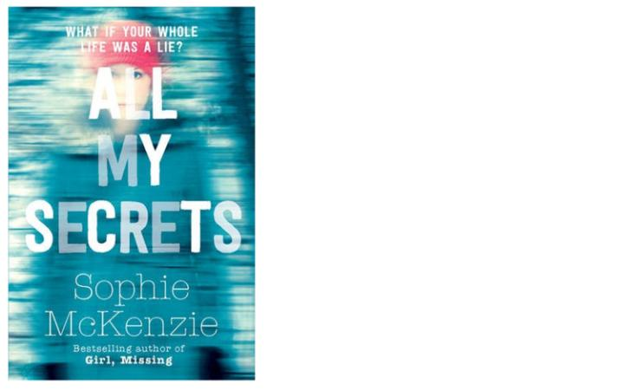
26. KILLER GAME BY KIRSTY McKAY (CHICKEN HOUSE)
I enjoyed Undead and although there are no zombies in Kirsty McKay's new novel Killer Game, there are plenty of twists and dark humorous turns in this thriller set in an exclusive boarding school on an isolated Welsh island. Killer Game is a whodunit, as teenager Cate tries to identify the real suspects in what seems to be a fake murder game that is turning increasingly deadly. Cate is an enjoyable main character (she says of her friend Marcia that "she likes collecting losers and loners; she collected me, after all") and although it's long, at 369 pages, it breezes by as you are engrossed in whether Cate can find the culprit … before it’s too late. MC
27. ALL MY SECRETS BY SOPHIE McKENZIE (SIMON & SCHUSTER)
It's GCSE exam time when Evie Brown's world is turned on its head. Why has the 15-year-old been left £10million by a birth mother she never even knew existed? Sophie McKenzie knows how to plot a taut mystery story and the twists of All My Secrets keep you glued. Evie ends up at a facility for troubled teenagers on the mysterious island of Lightsea (I liked the line about "insane hippy alert" for the people running the camp) and she starts seeing ghosts. Then the real danger begins. There's romance and thrills in this gripping psychological thriller. MC
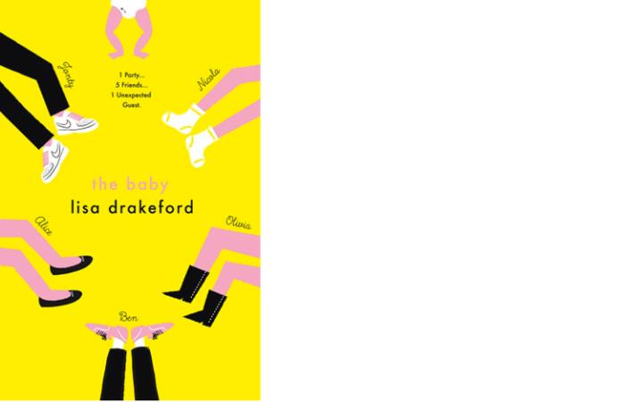
28. THE BABY BY LISA DRAKEFORD (CHICKEN HOUSE)
The cover of Lisa Drakeford’s debut YA novel The Baby might be a bright, sunny yellow – but inside, there’s a surprising amount of darkness. The book opens with a teenage girl, Nicola, locking herself in the bathroom during her best friend’s 17th birthday party and giving birth on the floor. The father of the baby is soon revealed as Jonty: the troubled, jealous boyfriend of Nicola’s best friend Olivia. From this painful, messy beginning, we launch headfirst into the – painful, messy – lives of five different characters: Nicola, Olivia, their gay friend Ben, Jonty and Olivia’s misfit younger sister, Alice. As we move through the first five months of baby Eliza’s life, each new voice brings new insights and revelations – and, in the final chapter, a completely unexpected twist.
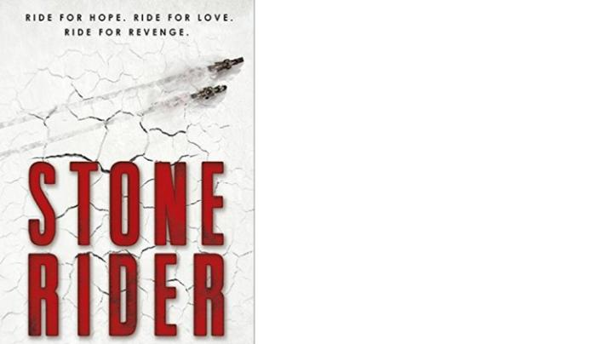
The language is unfussy but emotionally charged, and all five of the book’s characters feel like real teens (a testament, perhaps to the fact that the author, a learning support practitioner, has spent years working with young people). The issues touched on are bleak, to say the least: as well as the harsh realities of being a teenage mum – sick-stained clothes, money struggles, feeling cut off from your friends – there’s also violence, a young man facing up to the trauma caused by his own absent parents, and cruel schoolyard bullying. Crucially, however, the book is also brimming with humour and hope: it’s key themes are the importance of friendship, and the possibility of redemption. The final scene, in which a character finds himself at a party, overwhelmed by feelings of happiness and love – “his blood and his breath are buzzing with it” – is beautifully optimistic: a reminder that being young is an exhilarating time, as well as a terrifying one. RH
29. STONE RIDER BY DAVID HOFMEYR (PENGUIN)
Sulphur storms, wolves and scorched earth all abound in David Hofmeyr's futuristic thriller Stone Rider, about a teenager called Adam Stone who wants to escape the desert town of Blackwater. His way out could be a perilous bike race. There's romance (the slightly flat almond-eyed Sadie) in a dystopian tale with a western feel. The strongest parts of this debut novel come towards the end with the pacy account of the long, winding race. MC ★★★☆☆
30. ONE BY SARAH CROSSAN (BLOOMSBURY)
Grace and Tippi are literally joined at the hip. They are the rare ischiopagus tripus type of conjoined twin. Their appearance brings out the worst in some people. "Around us, people all morph into an asshole," says Tippi. Facing new people is a daunting and real prospect given the 16-year-olds are about to start school. Sarah Crossan, whose previous YA novel Apple and Rain made our best YA books of 2014, finds a wonderful way in One to mix the sharpness of their situation (people calling the girls devil's spawn or asking how many vaginas they have) with the subtle and shifting emotions of what it must be like to be them. The book, written in fluent and powerful free verse, is almost like a collection of moving poems. The brief chapter/poem In the Dark, for example, describes Grace's feelings as she lies in bed while Tippi is snoring next to her, pondering what it would be like to do just as only she wants. The novel has bleak humour, too, as when the girls decide on whether to sell their story to help their financially-strapped parents. "Step up, step up, see the two-headed girl play badminton," Graces jokes.
The book muses on friendship, solitude, love and identity. It also raises philosophical questions about surgery on conjoined twins and the threat of genetic engineering. But with One you should just read, think, enjoy and weep, because the novel is quite simply an achingly sad and beautiful story about what makes any of us human. MC ★★★★★
31. THE BIG LIE BY JULIE MAYHEW (HOT KEY BOOKS)
"What choice did I have but to do along with it?" A moral question that underpins much of The Big Lie, a challenging YA book by Julie Mayhew set in a 2014 Britain that is under Nazi Rule. Teenager Jessika Keller is raised in a hard-core English Nazi family and as a dutiful daughter seems to accept the idea that she should just be a pure, potential baby-machine to populate the master race. When her friend Clementine dares to question society, Jessika also begins to doubt the truth of what her mother and father have taught her. The Big Lie is a compelling and mysterious tale of protest, obedience and identity and a novel to make you think. MC ★★★★☆
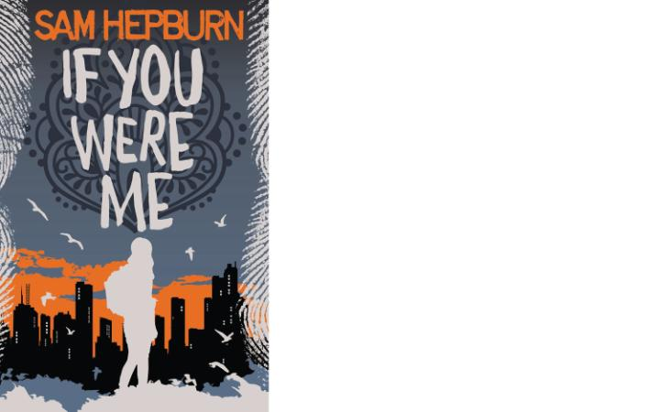
32. PATRICK NESS: THE REST OF US JUST LIVE HERE (WALKER BOOKS)
While some of their classmates are engaged in a series of fatal encounters with a group of immortals, Mikey and his friends are just trying to pass their high school exams and get a prom date. As the tag-line of this witty subversion of the fantasy genre runs: “Not everyone has to be the chosen one.” At the beginning of each chapter, Patrick Ness summarises what’s going on with the so-called “indie kids” who are trying to save the world. Then he lets his narrator, 17-year-old Mikey, get on with his story about friendship, romance and teenage neuroses. As Mikey explains: “The indie kids, huh? You’ve got them at your school, too. That group with the cool-geek haircuts and the charity shop clothes and names from the Fifties. Nice enough, never mean, but always the ones who end up being the Chosen One when the vampires come calling or when the alien queen needs the Source of All Light or something.” Ness is one of the most successful children’s writers around and has twice won the Carnegie Medal. The Rest of Us Just Live Here is a risky literary joke: a parody of teenage fantasy fiction. Review by Molly Guinness ★★★☆☆
33. LOUISE O'NEILL: ASKING FOR IT (QUERCUS)
"I am being ripped apart at the seams, my insides torn out until I am hollow," says Emma O’Donovan. When we first meet Emma, she is 18, full of life, and the most beautiful girl in Ballinatoom. By then end of Asking for It, she just wants to be erased, to fade away. This is because she has been brutally gang-raped and subsequently, when she goes public, subjected to an appalling campaign of vilification and humiliation. This is small town hypocrisy and sexism in the age of the smartphone.
Louise O'Neill, whose debut YA novel was the witty and unsettling Only Ever Yours, takes the brave step of making Emma a vain and somewhat unpleasant character at the beginning. That's the point. Rape is the issue, not a debate about any character flaws of the victim. It's hard not to wince when reading the novel. "Slut. Bitch. Skank. Whore. You were asking for it," people post on her Facebook page. Graphic pictures taken during the assault are posted. Twenty boys who were in her kindergarten class rate her naked, abused body. "I looked at the marks to see what they really thought of me, And I wished I was dead."
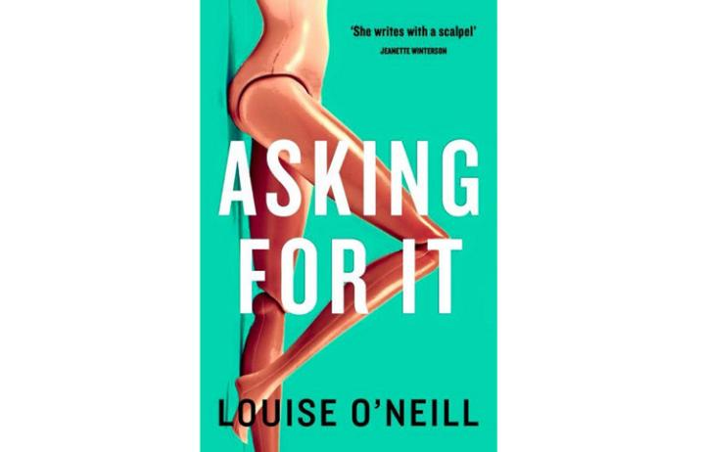
PLEASE NOTE: The final 60 pages are powerful and distressing. We see the effects on her family life, as she weighs up whether to go through with a painful court case in a country where the rate of conviction for rape is only one per cent. She is depressed, full of guilt and having panic attacks. She doubts that her parents truly accept that it wasn't her fault. There is a heart-breaking moment when her mother witlessly refers to the rapists as being "good boys really, this just got out of hand". It's like a knife through Emma's heart. This is not an anti-man book, though. Two of the strongest, most sensitive, characters are t her friend Conor and her brother Bryan.
Asking for It is a brave and important book about rape culture, sexism and victim-blaming in modern society. Think for a moment, too, about this: it is estimated that around 85% of rapes are never even reported to the police in the first place. People should read Asking for It but be prepared for an ending that is as pitiful as it is honest. MC ★★★★★
34. RHIAN IVORY: THE BOY WHO DREW THE FUTURE (FIREFLY)
Two boys are linked by parallel stories in this atmospheric thriller from Rhian Ivory. Blaze and Noah are both 15 and both live in the same village, Sible Hedingham. Both have the same ability, to draw the future. Is it a gift or a curse? What makes the story so absorbing is that Noah is a modern teenager while Blaze is a boy accused of witchcraft in the 1860s. I liked the historical feel to the Blaze chapters, and Noah is an engaging character, especially with his insecurities over a blossoming romance with Beth. Secrets start to emerge as danger grows and Ivory keeps the tension high in this taut novel. MC ★★★★☆
35. LINDA DAVIES: LONGBOW GIRL (CHICKEN HOUSE)
The popularity of the Hunger Games was apparently responsible for an outbreak of enthusiasm for archery among young women – and now Longbow Girl, the first YA book from author Linda Davies, could continue the trend.
Set in the Welsh mountains – a skilfully evoked landscape, teeming with drama and history – the book follows teenager Merry Owens. Despite having lost an eye in an accident several years ago, Merry is a skilled archer: a tough, resilient “longbow girl”, descended from a long line of longbow men. But when a mysterious archaeological discovery on her family’s land plunges her into danger, Merry needs more than archery to survive.
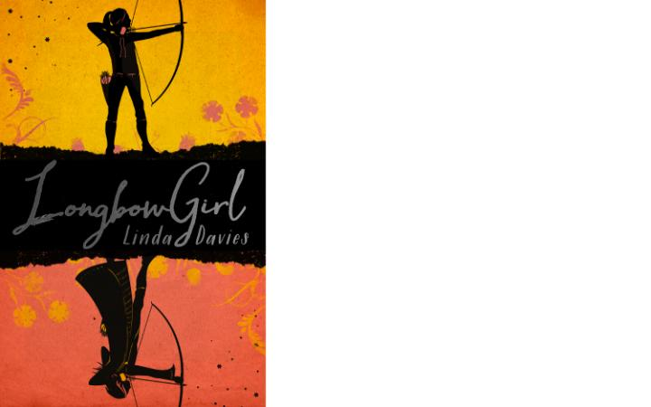
The book is pitched at the slightly younger end of the YA spectrum, but older readers should also find a lot to enjoy. Davies has previously written thrillers for adults, and clearly has a knack for pacey drama: things hurtle along nicely, and there’s some sort of twist or reveal in practically every chapter. The book also isn't afraid to confront some of the harsher realities of rural life: the first chapter sees Merry forced to shoot a beloved horse, after the animal is chased and attacked by a neighbour's dogs.
The plot eventually veers into supernatural territory – it’s probably not spoiling too much to say that there’s a time travel element – but real-life issues, such as money troubles, Merry’s fraught relationship with the upper class parents of her best friend, and the challenges of living in a remote area, are carefully blended with the more fantastical elements, ensuring that the danger always feels plausible. RH ★★★☆☆
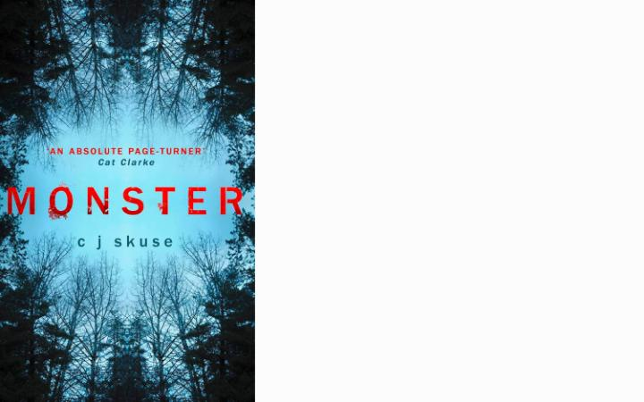
36. CJ SKUSE: MONSTER (MIRA INK)
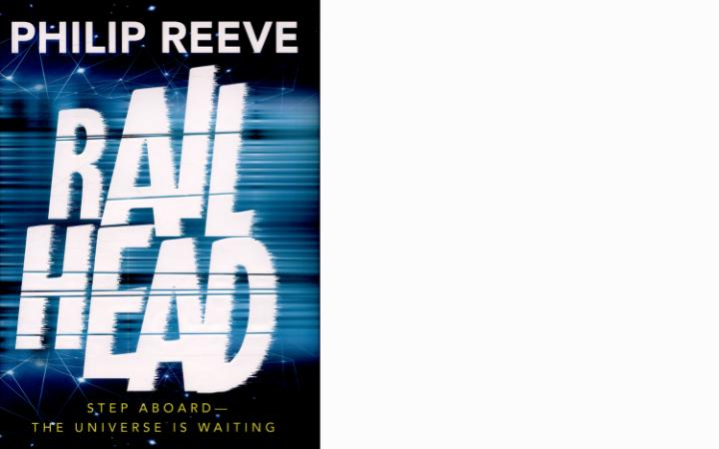
CJ Skuse is one of the most consistently entertaining YA writers around and Monster is another rollicking adventure. The gore starts in the second paragraph (with a dead school gerbil called Rafferty) and continues to the end of a thriller/chiller set in the prestigious boarding school Bathory. There's a hint of girls Hogwarts but with mayhem substituted for magic. Things start to turn dark when main character Nash (16) has to stay in the school over Christmas while her parents hunt for her brother, who is lost in the Colombian rainforest. The dialogue is snappy, the nicknames witty (the Golden Snitch, Mrs Stool-Softener) but you might not want to read the final chapter alone in the house . . . or while you're eating . . . as you find out the truth about the Beast of Bathory. Great fun. MC ★★★★☆
37. PHILIP REEVE: RAILHEAD (OXFORD UNIVERSITY PRESS)
Philip Reeve's fast-paced thriller is set in the Network Empire, a future human civilisation that is built around a network of railway lines that criss-crosses the galaxy, passing between worlds through hyperspace portals called K-gates. Railhead draws you in immediately. It's beautifully written ("giant gas planets tilting their rings like the brims of summer hats across a turquoise sky") and there is something wonderfully romantic about the author's use of trains instead of space ships. Railhead trains laugh softly to themselves or make "high, shuddering klaxon-shriek death cries". Into this futuristic world is thrown a young petty thief called Zen Starling, who is hired by a master criminal called to steal a mysterious black orb. His adventure is the core of the story, which will appeal to readers of different ages as well as young adult fiction fans. Although the technology is inventive and dazzling, the emotions of the characters (even the robot who wants freckles) draws you in wholeheartedly. Railhead is superb. MC ★★★★★
38. ANNABEL PITCHER: SILENCE IS GOLDFISH (INDIGO)
The new novel from Annabel Pitcher, author of My Sister Lives on the Mantelpiece and Ketchup Clouds, begins with a bang, as 15-year-old Tess Turner declares that her father, Jack, is "number one enemy after what I saw on his computer". Jack's 617-word blog shatters her world and she becomes a selective mute. We learn what Tess is thinking only through her internal dialogue with a goldfish-shaped torch. She becomes as isolated as Pluto, to escape a world of "fibs and mistruths". Pitcher writes clearly and elegantly and the novel is full of her trademark wit - there's a risque joke about Luke Skywalker and his Lightsaber and I liked the reference to Tess being a "hashtag-hypocrite". But Pitcher is also dealing with meaty subjects: bullying, family disharmony and the need to belong. We live in a world where teenagers are under tremendous pressure both to conform and to be seen as popular extroverts. The reality? "We're all scared, deep down," says the likeable love interest Henry. A thought-provoking read. MC ★★★☆☆

