Hampshire Book Award 2018 – Winner
The winner of the 2018 Hampshire Book Award is ‘Instructions for a Second Hand Heart’ by Tamsyn Murray.

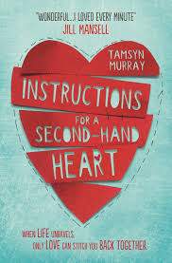

The runner-up was ‘A Dangerous Crossing’ by Jane Mitchell.
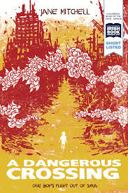

HAMPSHIRE BOOK AWARD: Shortlisted titles 2017:

My Name's Not Friday by Jon Walker
The Bubble Boy by Stewart Foster
Night Vision by Ella West
Railhead by Philip Reevel
River of Ink: Genesis by Helen Dennis-WINNER
Island by Nicky Slinger

PREVIOUS WINNERS:

2018- River of Ink:Genesis by Helen Dennis.

2017 - River of Ink:Genesis by Helen Dennis

2016 - Looking at the Stars by Jo Cotterill

2015 - The Screaming Staircase by Jonathan Stroud

2014 - Hostage by Chris Bradford

2013 - My Sister Lives on the Mantelpiece by Annabel Pitcher

2012 - Half Brother by Kenneth Oppel

2011 - Time Riders by Alex Scarrow

2010 - Hunger Games by Suzanne Collins

2009 - Dogfight by Craig Simpson

2008 - Skulduggery Pleasant by Derek Landy

2007 - Percy Jackson and the Lightning Thief by Rick Riordan

2006 - Spook's Apprentice by Joseph Delaney

2005 - Private Peaceful by Michael Morpurgo

2004 - A Little Piece of Ground by Elizabeth Laird

2003 - Skeleton Key by Anthony Horowitz

