5 Classic Novels That Are Short Enough To Finish In One Sitting
By Sadie Trombetta (Bustle Website).
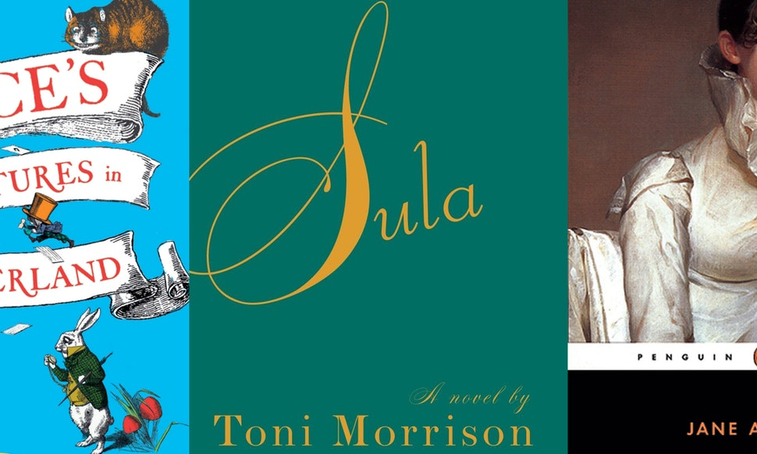
Classic novels have a bad reputation for being too long, which is why so many readers avoid them. Who has the time nowadays to sit and read a 1,000 page book? While it is true there are plenty of classic novels with page counts in the quadruple digits, there are also a lot of incredible classic novels short enough to finish in a single weekend.
If one of your summer reading goals is to get through more classics, start it off easy with one of these celebrated novels that are short enough to finish in a single weekend.
As always, parental guidance is advised prior to your child begins reading.

'Alice's Adventures in Wonderland' by Lewis Carroll
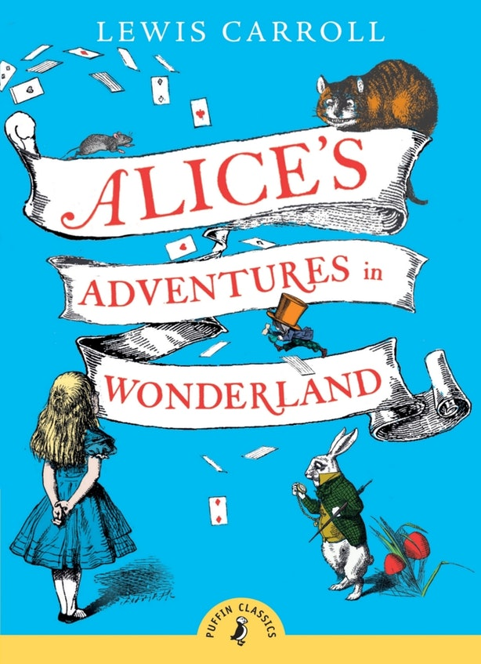
Paperback Page Count: 86
Did you know that Lewis Carroll's beloved story about a young girl who falls down a rabbit hole into a magical world is under 100 pages? A fun and fantastical story you may know but haven't read yet, Alice's Adventures in Wonderland is a fun and easy way to cross a classic off your reading list.

'The House on Mango Street' by Sandra Cisneros
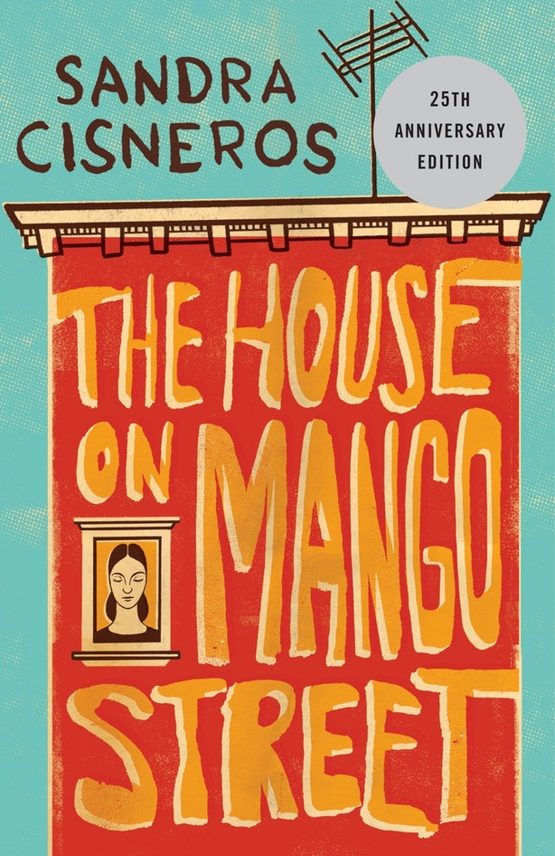
Paperback Page Count: 110
A short by powerful read, The House on Mango Street tells the story of Esperanza Cordero, a young Latina girls coming of age in Chicago. Told in a series of beautiful vignettes, it follows Esperanza as she figures out who she is, and who she wants to be. A touching story fit for all ages, consider this wondrous tale required reading.

'Sula' by Toni Morrison
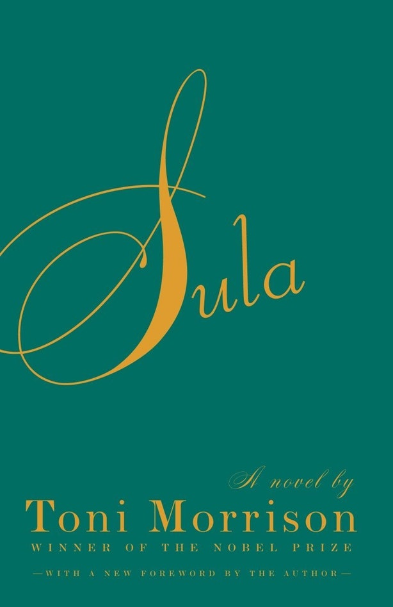
Paperback Page Count: 192
In this haunting story of female friendship, two women who have known each other since childhood are torn apart by an unspeakable betrayal. Is their bond broken forever, or is their love and loyalty enough to withstand the heartache? A truly remarkable work of fiction, Sula is a stunning classic you will want to finish in one sitting.

'Persuasion' by Jane Austen
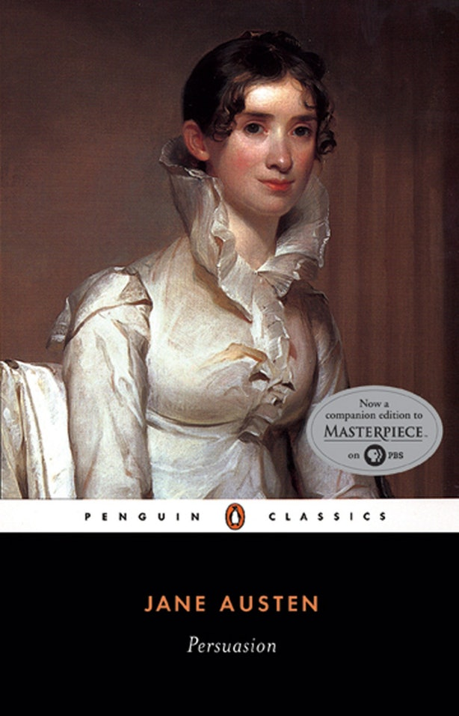
Paperback Page Count: 272
While some of Jane Austen's books are on the longer side — her classic Pride and Prejudice is around 480, and Emma is over 500 pages — the beloved novelist's last completed work falls under the 300 mark. A witty romance, Persuasion tells the story of 27-year-old Anne Elliot, whose marriage prospects are limited after breaking off an engagement eight years earlier. But when she encounters her handsome former fiancé years later, she just might get a second chance at happily ever after.

'Slaughterhouse-Five' by Kurt Vonnegut
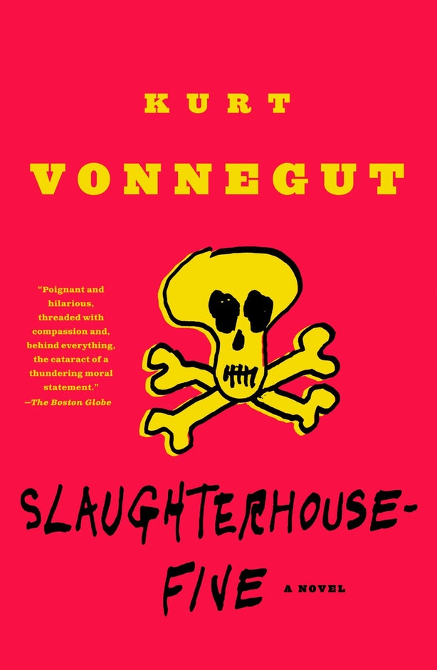
Paperback Page Count: 288
Slaughterhouse-Five is a short but incredibly satisfying read. It tells the story of Billy Pilgrim, an American soldier and prisoner-of-war caught in the firebombing of Dresden who becomes "unstuck in time." A genre-bending satire that will have you laughing out loud, this anti-war narrative is a must-read.

